Yakima Bull Trout Trap, Transport, and Monitoring Project

**2024 Progress Report**

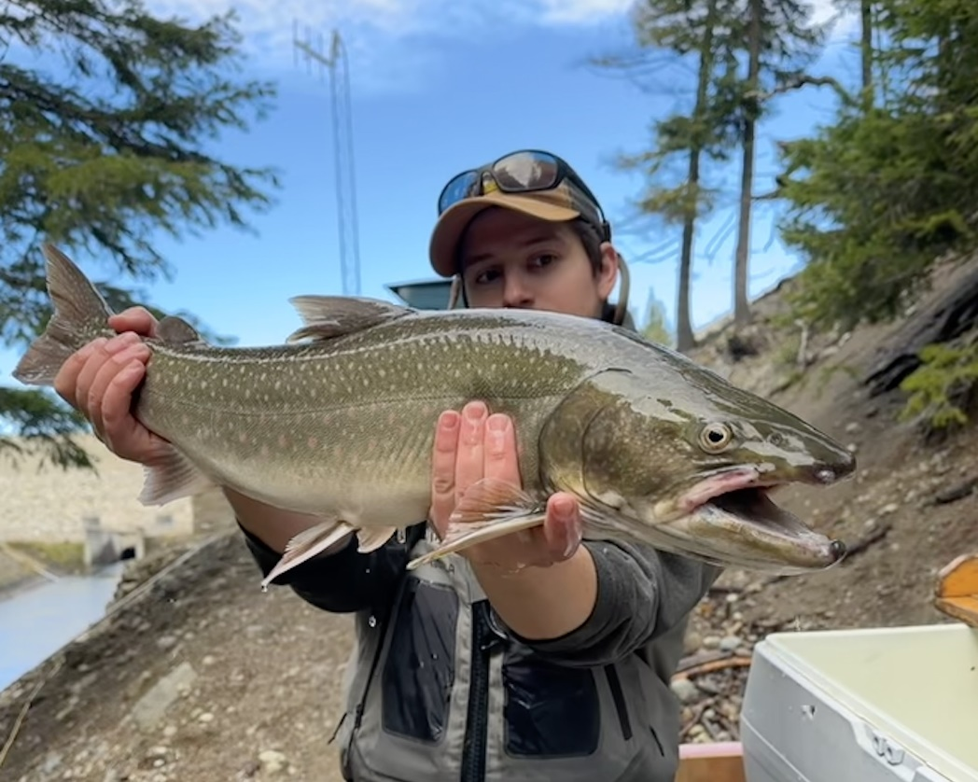

**U.S. Fish and Wildlife Service**

**Mid-Columbia Fish and Wildlife Conservation Office**

**Yakima Sub-Office**

**1917 Marsh Road**

**Yakima, WA 98901**

**June 10, 2025**

Authors:

Brittany Beebe, Connor Cunningham, Blake Hamilton, and Craig Haskell

(USFWS, Mid-Columbia Fish and Wildlife Conservation Office)

and

Jennifer Von Bargen (USFWS, Abernathy Fish Technology Center)

# Foreword

Bull Trout (*Salvelinus confluentus*) are listed as Threatened under the Endangered Species Act with recovery strategies divided into six recovery units. The Yakima River Basin is one of 24 core areas within the Mid-Columbia River Recovery Unit, which stretches across eastern Washington, eastern Oregon, and portions of Idaho. Historically, the Yakima River Basin was home to 15 genetically distinct populations of Bull Trout, 3 of which are now extirpated. Bull Trout in the Yakima River Basin exhibit three generally accepted life history types: resident, fluvial, and adfluvial. In the Yakima River Basin, most Bull Trout populations exhibit an adfluvial life history characterized by spawning and juvenile rearing in tributary habitats and sub-adults and adults living primarily in reservoirs. A major threat to Yakima Basin Bull Trout is loss of habitat connectivity and migration corridors due to the construction of dams without fish passage. Fish exit headwater systems through dam outlet works and are unable to return to their natal streams to spawn (U.S. Fish and Wildlife Service 2015). Until permanent fish passage is installed, interim trap and haul is used to transport Bull Trout upstream of dams so that entrained individuals can access their natal spawning tributaries.

A study on the North Fork Tieton River to assess Bull Trout passage at Clear Creek Dam from 2012-2015 indicated a need to improve upstream fish passage (Thomas et al. 2013, 2014; Thomas and Monk 2015, 2016). As a result, a trap and haul program was implemented in 2016 at Clear Creek Dam as an interim fish passage measure. Given the success of the program at Clear Creek Dam (Thomas and Monk 2015, 2016; Thomas et al. 2017, 2018), trap and haul was implemented at other dams in the Yakima River Basin (Bumping, Kachess, and Keechelus dams in 2019; Tieton Dam in 2020). As reported here for 2024, we collected 47 unique Bull Trout below Clear Creek Dam, 19 Bull Trout below Keechelus Dam, and 3 Bull Trout below Kachess Dam. Twenty North Fork Tieton River-origin fish were transported over Clear Creek Dam, 20 Gold Creek-origin fish were transported over Keechelus Dam (including 1 captured below Kachess Dam), and 2 Kachess River-origin fish were transported over Kachess Dam. We did not collect any Bull Trout below Bumping or Tieton dams in 2024 during trap and haul.

Monitoring sites detected the movement of Bull Trout transports throughout our study area. Of the 20 Bull Trout transported above Clear Creek Dam in 2024, we detected 9 individuals, presumably spawners, at Passive Integrated Transponder (PIT) antennas in the North Fork Tieton River. Two Bull Trout ascended the defunct fish ladder at the Clear Creek Dam spillway, one a North Fork Tieton River-origin fish that ascended the ladder in August when water temperature was 18.9 °C, and another, a South Fork Tieton River-origin Bull Trout that was detected in November shortly after being detected in the stilling basin. Only one other tagged fish, a Brook Trout/Bull Trout hybrid, has ascended the ladder since monitoring began in 2016. In the upper Yakima Basin, 8 of the 20 transports from 2024 were detected at the lower Gold Creek site, but none were detected in the upstream site.

Detections from a PIT antenna array below Keechelus Dam coupled with our trap and haul work indicated that at least 34 Gold Creek origin-Bull Trout have been entrained at Keechelus Dam while our acoustic telemetry work in Keechelus Reservoir revealed that La Salle Bull Trout spent most of their time during summer and fall in the forebay where they had an entrainment probability of nearly 23% in the five-month period since release.

# Goals and Objectives

The ongoing goals of the Bull Trout Transport Project are to increase viability of Bull Trout populations and provide connectivity for entrained fish disconnected from natal spawning tributaries above Bumping, Clear Creek, Kachess, Keechelus, and Tieton dams. Our specific objectives were to: 1) capture Bull Trout in stilling basins directly below Bumping, Clear Creek, Kachess, Keechelus, and Tieton dams, 2) implant PIT tags in captured Bull Trout and obtain tissue samples for rapid response genetic testing, 3) implant acoustic tags in a subset of Bull Trout collected through trap and haul and from the La Salle rescue-and-rear program, 4) snorkel when feasible to evaluate the efficacy of collection methods and identify other fish species present, 5) transport and release tagged Bull Trout above the dams to provide access to spawning tributaries as determined from rapid response genetic testing, 6) use PIT tag antenna sites to monitor the movement and survival of transported Bull Trout, and 7), use acoustic receivers to monitor acoustically tagged Bull Trout in Keechelus Reservoir.

# Methods

## Study Area

Bull Trout trap and haul occurred in two main regions of the Yakima River Basin: the upper Yakima River Basin and the Naches River Basin.

In the upper Yakima River Basin, collection occurred in the stilling basins of Kachess and Keechelus dams. These dams are located upstream of Easton Dam, which impounds the Yakima River near Easton, Washington to form Easton Reservoir, a 0.83 km2 (205-acre), shallow reservoir situated at the confluence of the Yakima and Kachess rivers. The ‘Keechelus Arm’ of the Yakima River extends northwest from Easton Reservoir about 18 km upstream to Keechelus Dam, which impounds Keechelus Reservoir. The lower Kachess River extends north 1-km upstream from Easton Reservoir to Kachess Dam, which impounds Kachess Reservoir. Kachess Reservoir is comprised of Little Kachess Lake on the north end of the reservoir and Big Kachess Lake. The lakes are connected by The Narrows that becomes a narrow, shallow stream as reservoir level recedes, but is a large and deep (~10 m) channel at full pool (Figure 1).

In the Naches River Basin, collection attempts occurred within the stilling basins of Bumping, Clear Creek, and Tieton dams. Bumping Dam impounds Bumping Reservoir and is located on the Bumping River, a tributary of the Naches River. The Bumping River flows northeast, where it joins the American River and then the Little Naches River, to form the Naches River. The confluence of the Bumping and Little Naches rivers is about 89 km upstream of the Naches and Yakima River confluence near Yakima, Washington. Tieton Dam, which impounds Rimrock Reservoir, is located on the Tieton River, 35 km upstream of the confluence of the Tieton and Naches rivers near the town of Naches, Washington. About 1 km upstream of Rimrock Reservoir, Clear Creek Dam impounds the confluence of the North Fork Tieton River and Clear Creek to form Clear Creek Reservoir.

### Monitoring Locations

PIT antennas and arrays (i.e., more than one antenna per site) were used to monitor the movement of Bull Trout throughout the study area and were collaboratively maintained with Yakama Nation Fisheries. Monitored spawning tributaries in the upper Yakima River Basin included Gold Creek, a tributary of Keechelus Reservoir, as well as Box Canyon Creek and the upper Kachess River, tributaries of Kachess Reservoir. There were two sites on Gold Creek: a lower antenna (G90; 47.39096, -121.38244) at river km 0.5 between the eastern span of I-90 and National Forest Road 4832, and an upper array (UGC1, UGC2; 47.41381, -121.36446) at river km 4. There were two sites on Box Canyon Creek: an array in Box Canyon Creek (BOX1, BOX2; 47.35952, -121.24575) at river km 0.2, and a temporary antenna site that operated during October in the Box Canyon Creek flume (BOX3; 47.36473, -121.24316). There were two sites on the upper Kachess River: a downstream array (KACL, KACL2; 47.40525, -121.23914) and an upstream antenna (KR1; 47.41560, -121.23904) that were located 0.2 and 1 km upstream of Kachess Reservoir, respectively. In addition to spawning tributaries, monitoring also occurred in The Narrows, the Gold Creek Pond outlet channel (GCP; 47.399423, -121.376507), Cold Creek (a tributary of Keechelus Reservoir), and the mainstem Yakima River located downstream from Keechelus Dam. Two temporary antennas were placed in Cold Creek (COLD; 47.36748, -121.39359 and COLD2; 47.367683, -121.391059), approximately 0.1 km and 0.4 km downstream from a barrier culvert. A temporary antenna was also placed in The Narrows (NARN; 47.35519, -121.23773) during the time when pool elevation decreased in Kachess Reservoir and the area between Little and Big Kachess lakes became a shallow riverine channel. Lastly, there was an array site (KCH1, KCH2, KCH3; 47.32077, -121.33599), located at river km 345 on the Yakima River, approximately 0.2 km downstream from Keechelus Dam (Figure 1).

Monitored spawning tributaries in the upper Naches River Basin included Indian Creek, the South Fork Tieton River, tributaries of Rimrock Reservoir, as well as the North Fork Tieton River. Hereafter, references to the North Fork Tieton River refer to the section of the river that is upstream of Clear Creek Reservoir unless otherwise specified. There were two antenna sites on the South Fork Tieton River: a lower site (LSFT; 46.62399, -121.13116) and an upper site (SFT; 46.59678, -121.21034) located at river kms 0.5 and 8.5, respectively. An array site in Indian Creek (IND1, IND2; 46.64615, -121.25242) was located at river km 0.9. Multiple antennas were located near Clear Creek Dam: one in the outlet channel (OCH; 46.62805, -121.27001), 80 m downstream from the dam, one at the upstream end of the fish ladder (ULD; 46.62933, -121.27280) and one at the downstream end of the fish ladder (LLD; 46.629353, -121.271792), both within the spillway channel, north of the dam. Two antenna sites were located on the North Fork Tieton River: a lower site (NFT; 46.62165, -121.30086) at river km 1.2 and an upper site (UPNFT; 46.57970, -121.35352) at river km 9.5 (Figure 1). We do not monitor Deep Creek, a spawning tributary of Bumping Reservoir in the Naches River Basin, because we have only tagged one individual in the Bumping River watershed. Further, monitoring is challenging because the active stream channel of lower Deep Creek oscillates between a west and east channel. Should we collect and tag more Bull Trout there in the future, we will reconsider monitoring in Deep Creek.

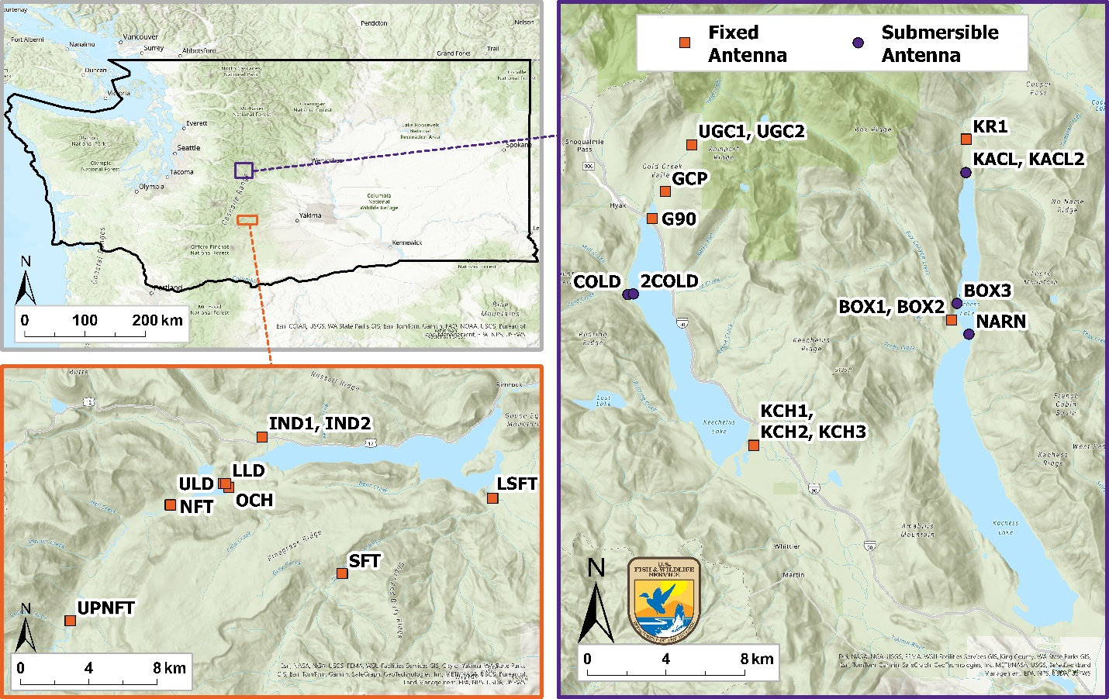

**Kachess Dam Dam**

**Clear Creek Dam Dam**

**Tieton Dam Dam**

**Keechelus Dam Dam**

Figure 1. Map of study sites in the upper Yakima River Basin (right), upper Tieton River Basin within the Naches River Basin (lower left), and their location within Washington State (top left). Orange squares depict sites with permanent, fixed PIT antennas and purple circles depict sites with portable, submersible PIT antennas. The map includes Kachess, Keechelus, Clear Creek, and Tieton dams. Bumping Dam (upper Naches River Basin) is not pictured as no PIT monitoring occurs there.

## PIT Antenna Configuration and Installation

We deployed either a single PIT antenna or an array (two antennas placed approximately 20 m apart) at each fixed monitoring site except for the Keechelus Dam outlet channel site (KCH) that consisted of five antennas oriented in three channel-spanning rows (KCH1-3). Each antenna consisted of a 24-V PIT tag reader motherboard (IS1001, Biomark Inc., Boise, Idaho) housed within a waterproof case (Pelican Products, Inc., Torrance, California) that was attached to external antenna wires and power cords. Antenna wire (12-gauge copper Litz wire) was coiled 2-4 times through 1-inch polyethylene piping. Ends of the piping were connected to a 5.1-cm diameter, 3-way PVC ‘T’ fitting. Both ends of the coiled wire were soldered to a collection of capacitors which were chosen based on the inductance of the antenna coil and attached to the antenna motherboard via a hydrovolt cable (AK Industries, Rancho Domingo, California). DC power was supplied to the motherboard from four, 6-V batteries wired together in series, forming a 24-V configuration. Batteries were charged by 300W/24V solar panels (Grape Solar, Eugene, Oregon) mounted to a wooden frame that faced 120° - 150° (Southeast). Output from the solar panels was regulated by a solar controller (ProStar PS-15 or PS-30, Morningstar Inc., Newtown, Pennsylvania). The solar controller and batteries were housed in a steel storage chest (Ridge Tool Company, Elyria, Ohio). The Box Canyon Creek array was powered by a thermoelectric generator (TEG; Global Power Technologies, Calgary, Alberta, Canada) fueled by propane stored in a 94.6-L (25-gal) tank, which supplied 24V of continuous DC power to the array.

Antenna coils were installed in either a horizontal *pass-over* (i.e., flat-plate) or vertical *pass-through* configuration. Generally, flat-plate antennas are less susceptible to displacement from high water events and associated debris, whereas pass-through antennas better detect fish across a range of water levels but are more susceptible to damage during high water events.

Most monitoring sites were set up in a flat-plate configuration, lying flat on the creek bed from bank to bank (Figure 2). The piping housing the antenna coils was affixed to the stream bed using 0.8-cm (5/16-inch) barbed rebar anchors with 2.5-cm (1-inch) threadless eye nuts welded near the top of the rebar. The anchors were driven into the stream bed using a gas-powered post driver (Titan, Nevada, Missouri), and the antenna piping was secured to the anchors with nylon straps (NRS Inc., Moscow, Idaho). Pass-through antennas (Figure 3) were operated at lower Gold Creek (G90), the Clear Creek Dam fish ladder (ULD), and the upstream antenna at Keechelus Dam outlet channel (KCH1). At the lower site on Gold Creek and upstream antenna in the Keechelus Dam outlet channel, the antennas were about 2-m tall and spanned the entire width of the stream. An antenna support cable (1/2-inch, 1,250-lb Greenlee pulling tape) was affixed from one bank to the other, with each end attached to a 3.1-m U-channel signpost. Zip ties and/or nylon straps were used to affix the antenna to the support cable. The bottom portion of the pass-through antenna was affixed to the streambed following the same methods as the flat-plate configuration. A pass-through antenna was also installed at the upper section of the fish ladder at Clear Creek Dam but was sized to fit the upstream terminus of the fish ladder which was designed as an exit point for upstream migrating fish and an entry point for downstream migrating fish.

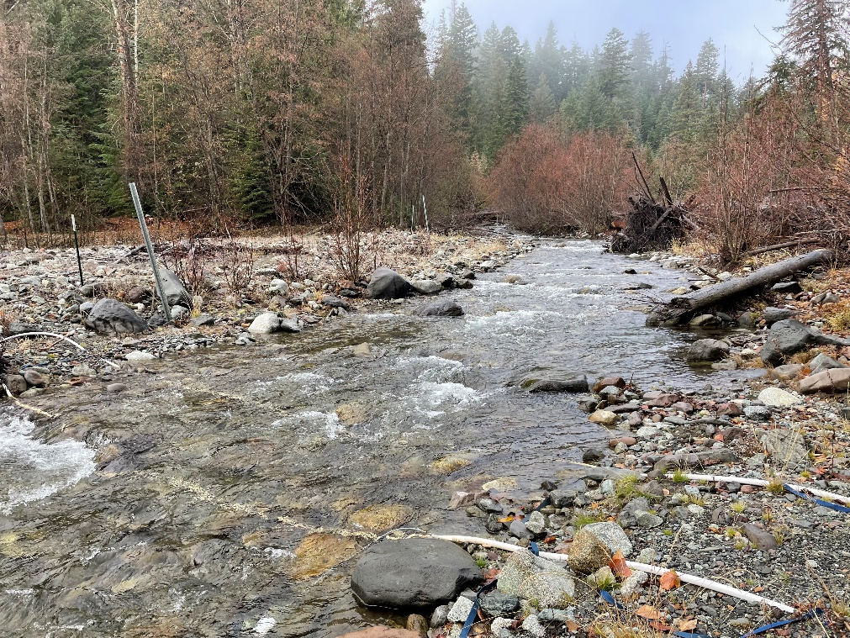

Figure 2. Example of a pass-over or flat-plate PIT antenna.

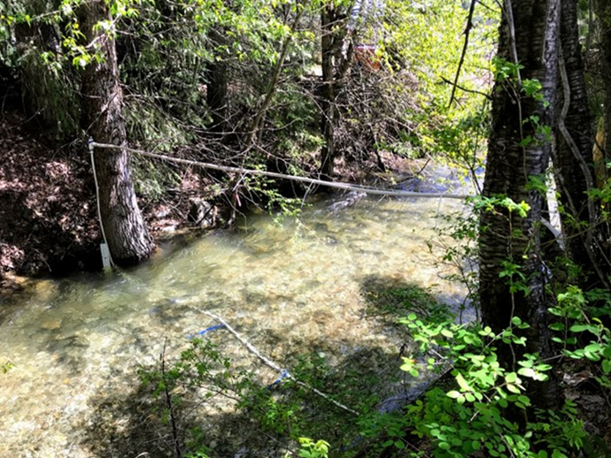

Figure 3. Example of a pass-through PIT antenna.

Submersible PIT antennas (Biomark Inc., Boise, Idaho) were deployed at five sites in 2024: the upper Kachess River (KACL, KACL2), The Narrows (NARN), the Box Canyon Creek flume (BOX3) as well as two sites in Cold Creek (COLD, COLD2). The submersible antenna is a 2-m diameter flat plate design, containing a waterproof housing for the IS1001 and a rechargeable battery pack (Figure 4). Batteries were swapped and recharged monthly. When deployed, the submersible antennas were tied off to a fixed object (e.g., tree, boulder) with twisted polypropylene rope and weighed down using large rocks or concrete blocks secured to the frame with nylon straps (NRS Inc., Moscow, Idaho). We also deployed water temperature loggers (Onset, Bourne, Massachusetts) at our antenna sites which continuously logged water temperature every 15 min.

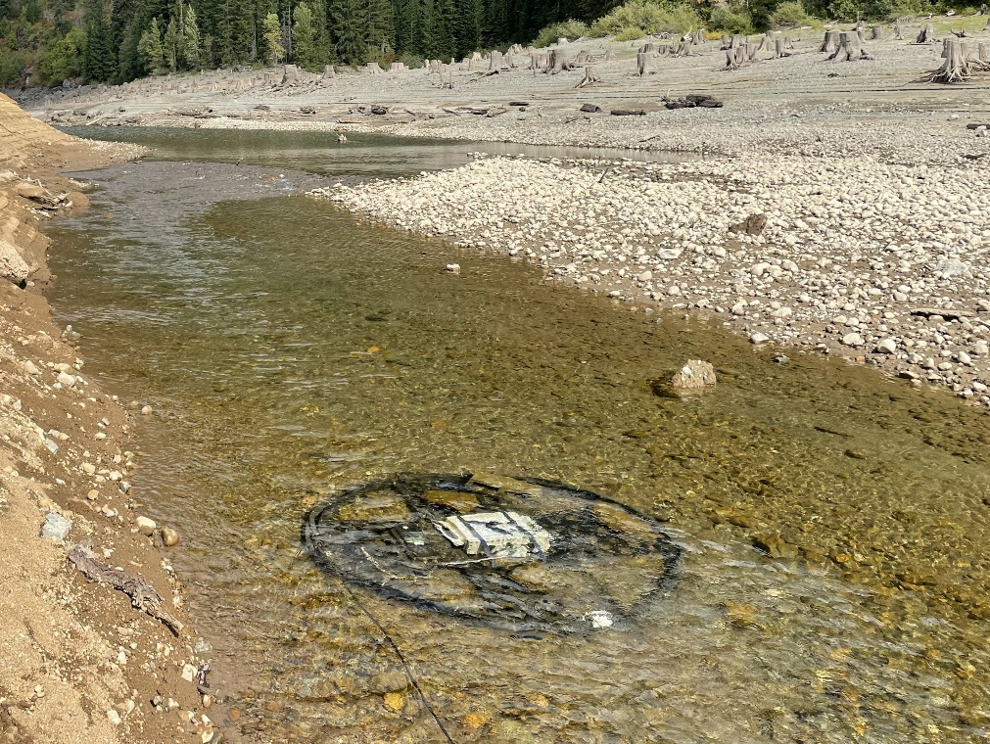

Figure 4. Example of a submersible PIT antenna.

## Acoustic Tag Monitoring

We deployed an array of 3 VR2W and 15 VR2Tx acoustic receivers in Keechelus Reservoir in 2024 (Figure 5). Receivers were manufactured by Innovasea Systems Inc. (New Bedford, Nova Scotia, Canada) and had a detection range of about 500 m (Taylor 2022). We placed 12 of the receivers within 500 m of each other in the Keechelus Forebay to study fine-scale movement and behavior near the dam intake. These receivers were deployed on June 4. Using this setup, we hoped to detect tags on multiple receivers and develop 3D movement tracks using triangulation. The remaining receivers were generally positioned along the centerline of the reservoir in a north-south orientation every km (Figure 6). These six northernmost receivers were deployed on May 13. All receivers were placed so they would allow year-round data collection across the range of depths from minimum to full pool including operation under the ice. We also placed a single receiver downstream in Easton Reservoir to detect acoustically tagged fish that might entrain at Keechelus Dam based on previous years data (e.g., Beebe et al. 2025).

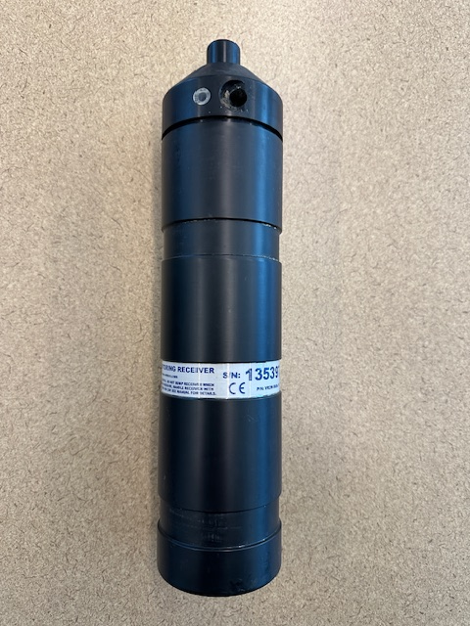

Figure 5. Example of an acoustic receiver deployed in Keechelus Reservoir in 2024.

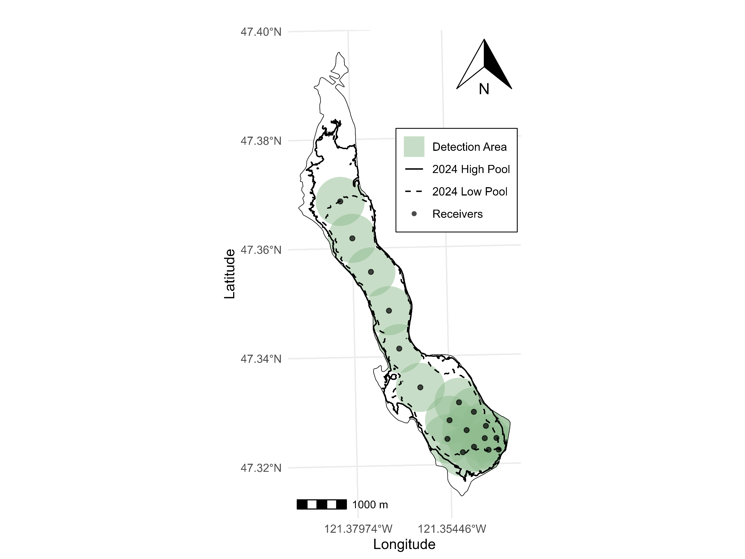

Figure 6. Map of Keechelus Reservoir with location of acoustic receivers (black points) and associated 500-m detection buffers (green circles). Bold, solid line indicates the extent of the reservoir at full pool in 2024 and the dashed line indicates the extent of the reservoir at minimum pool in 2024. The thin, solid line indicates the reservoir boundary.

## Fish Collection, Processing, and Release

### Collection

Sampling methods consisted of a combination of hook-and-line angling, snorkeling, and tangle nets. The sampling methods used at a particular stilling basin depended on water velocities suitable for safely deploying nets and snorkeling, water clarity suitable for snorkeling, and water temperatures within the range specified in our sampling permit for handling and tagging Bull Trout (i.e., < 15°C). We attempted to sample at least three times at each of the five stilling basins but continued to sample if fish were still present.

We sampled via hook-and-line angling with artificial lures and a single, barbless hook. This method was typically implemented for 1-2 hours depending on the number of fish captured. The crew mainly sampled in the stilling basin below the dams, but hook-and-line sampling also occurred downstream of the stilling basins at Clear Creek, Tieton, and Keechelus dams. We also sampled in the spillway channel at Clear Creek Dam.

Our snorkeling crew consisted of snorkelers and a data collector following Thurow and Schill (1996). We counted adult Bull Trout below each stilling basin after hook-and-line sampling, with the area snorkeled contingent on instream conditions at the time of the survey. Thurow and Schill (1996) found no significant difference between day and night abundances of adult Bull Trout, therefore we conducted our surveys during daytime. We also recorded counts of other fish species. Snorkeling was not conducted at Clear Creek and Tieton dams because of poor water clarity and high-water velocities.

After snorkeling, we deployed tangle nets either by placing them across stream reaches where snorkelers directed fish towards the nets, or by passively fishing without snorkelers. In both cases, nets were constantly monitored, and fish were immediately removed from nets using knot-free dip nets. Nets were constructed of 7.5-cm stretch mesh and 3.5-kg (8-lb test) monofilament and were cut as needed to minimize fish injury during capture. Tangle nets were not deployed at Kachess Dam.

Upon capture, Bull Trout were placed in a holding pen (0.9 x 1.2 x 1.8 m) constructed of perforated stainless steel with lockable latches that was submerged in an area of acceptable flow (Figure 7). The holding pen was used to protect Bull Trout until they could be released according to genetic test results. Bull Trout generally remained in the holding pen for 24 h.

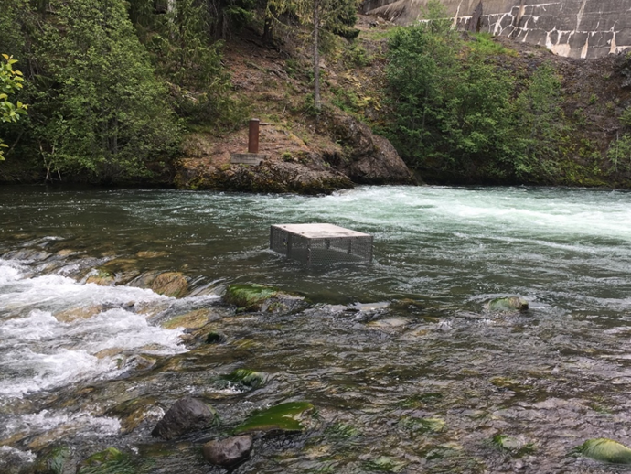

Figure 7. Stainless steel pen used for holding Bull Trout after collection and before rapid response genetic testing and transport to natal watershed.

### PIT tagging

Following collection, each fish was removed from the holding pen using a dip net and placed in a 75.7-liter (80-quart) cooler containing a buffered anesthetic solution using river water, 50 mg/L of MS-222, NaHCO3 buffer (i.e., baking soda), and StressCoat. MS-222 is acidic, so buffer was added until pH was approximately 7 as measured by a Eutech Instruments pHTestr20 (Cole-Parmer, Vernon Hills, Illinois). We removed fish from the solution when they were fully sedated (2-5 min), scanned them for a PIT tag using a HPR Lite Handheld PIT Tag Reader (Biomark, Boise, Idaho), and measured their length (fork and total length; mm). For individuals without a PIT tag, we used sterilized surgical scissors to collect a small tissue sample from the anal fin, which was placed in a vial of ethanol. We then inserted a FDX-12 PIT Tag (Biomark, Boise, Idaho) into the base of the dorsal fin (dorsal sinus) using a preloaded APT12 12-gauge needle and MK25 PIT Tag Implanter (Biomark, Boise, Idaho). PIT Tags measured 12.5 x 2.1 mm and operated at a frequency of 134.2 kHz. Processing generally took less than 1 minute. After recovery, Bull Trout were placed in a perforated 1-m long, 15-cm diameter PVC recovery tube, allowing fish to regain equilibrium before being returned to the holding pen. Tagged and processed fish were kept separate from unprocessed fish in the holding pen until all fish were processed.

After all fish were processed, the vials containing fin clips were delivered to the U.S. Fish and Wildlife Service (USFWS) Abernathy Fish Technology Center (Abernathy) for rapid response genetic assessment to determine population origin and to identify Brook Trout/Bull Trout hybrids (see Genetic Testing).

### Acoustic Tagging

We surgically implanted Bull Trout with two different acoustic tags both operating at a frequency of 69 kHz and manufactured by Innovasea (New Bedford, Nova Scotia, Canada). Bull Trout reared at the Yakama Nation’s La Salle Reconditioning Facility (hereafter La Salle) were implanted with V9TP tags. These tags had a 567-day tag life; measured 31 x 9 mm, weighed 4.9 g in air and 2.8 g in water. These fish were originally collected by WDFW from dewatering stretches of Gold Creek and transferred to La Salle (Union Gap, Washington) in summer 2023. During surgery an anesthetic solution was pumped across the gills during tagging using a variable speed portable sample pump (Model SP200, Global Water Instruments, College Station, Texas) and the fish were held for three weeks after surgery to allow for recovery. We also acoustically Gold Creek-origin Bull Trout encountered opportunistically during our trap and haul events at Keechelus and Kachess dams. Trap and haul fish were implanted with either a V9TP (n=7) or V13TP (n=6) acoustic tag. The V13TP tags had a tag life of 730 days, measured 41.5 x 13 mm; and weighed 11.3 g in air and 5.5 g in water.

For all tagging, acoustic transmitters were implanted internally into the visceral cavity through a 2-cm incision made with a #12D scalpel blade anterior to the pelvic fins. The incision was sealed with two or three interrupted nylon sutures. Some trap and haul fish implanted with acoustic tags were recaptures that were previously PIT tagged, but all others received a PIT tag in addition to the acoustic tag.

### Release

Fish were generally transported and released the following day upon receipt of genetic results. However, we released fish the same day of capture without first running genetics in November 2024 during which time the sequencing equipment at Abernathy was inoperable.

Bull Trout were loaded with a hand dip net into a transport vehicle outfitted with a large cooler filled with river water and oxygenated by a battery-powered aerator with air stones. Individual Bull Trout were then released via hand dip net into their respective reservoir as determined by the genetic assessment results. Hybrids were euthanized on site.

In the upper Yakima Basin, captured Bull Trout originate from Gold Creek, Box Canyon Creek, and the upper Kachess River. Bull Trout from Gold Creek (a Keechelus Reservoir tributary) move downstream through Keechelus Dam where they are collected and then transported and released back into Keechelus Reservoir. Bull Trout from Kachess Reservoir tributaries (Box Canyon Creek and Kachess River) move downstream through Kachess Dam or the adjacent spillway channel and migrate either back upstream to the base of Kachess Dam or downstream through Easton Reservoir and then upstream to the base of Keechelus Dam. These fish are transported and released into Kachess Reservoir. It is possible for Bull Trout to move downstream of Easton Reservoir (as has been confirmed by PIT detectors at the dam) and then possibly move back upstream into Easton Reservoir via the fish ladder there. Currently, the Easton Dam fish ladder does not have PIT antennas to detect fish moving upstream. Trap and haul fish identified as Gold Creek origin were released into the Keechelus Forebay while Kachess River-origin fish were released into Little Kachess Lake near the mouth of Box Canyon Creek so they would not have to navigate low water at The Narrows to access their spawning grounds. All La Salle fish implanted with acoustic tags were held for three weeks after tagging and released into Keechelus Reservoir near the mouth of Cold Creek.

Fish captured below Clear Creek Dam originate from Indian Creek, the South Fork Tieton River, or the North Fork Tieton River. Bull Trout from the North Fork Tieton River (Clear Creek Reservoir tributary) move downstream through Clear Creek Dam or an adjacent spillway channel and migrate back upstream to the base of the dam where they are collected (Thomas et al. 2017). These fish are transported upstream and released into the Clear Creek Forebay. Bull Trout originating from Rimrock Reservoir tributaries (Indian Creek and South Fork Tieton River) routinely migrate upstream to Clear Creek Dam but are not transported above the dam to Clear Creek Reservoir. These fish are instead released into the North Fork Tieton River directly downstream of the Clear Creek Dam stilling basin.

### Genetic Testing

We used a real-time genotyping and analysis method (DeHaan et al. 2011) to identify natal origin as well as Brook Trout/Bull Trout hybrids. Upon arrival of samples in the laboratory, genomic DNA was extracted twice from each individual fin clip to ensure consistency using a modified chelex extraction protocol (Miller and Kapuscinski 1996) with incubation at 55°C for 15 min, and then at 103°C for 8 min. Individuals were genotyped at the following 16 microsatellite loci: Omm1128, Omm1130 (Rexroad et al. 2001), Sco102, Sco105, Sco106, Sco107, Sco109, [Washington Department of Fish and Wildlife (WDFW) unpublished], Sco200, Sco202, Sco212, Sco215, Sco216, Sco218, Sco220 (Dehaan and Ardren 2005), Sfo18 (Angers et al. 1995) and Smm22 (Crane et al. 2004). Allele calling at each of these loci was previously standardized between our laboratory and WDFW Molecular Genetics Laboratory using a similar protocol to the one described by Stephenson et al. (2009) to facilitate data sharing. Several Bull Trout and Brook Trout loci have diagnostically different allele sizes and can be used to identify species and individuals with hybrid ancestry.

We used the baseline genotypes described by Small et al. (2016) to assign fish to population groups and evaluated the power of the baseline to accurately assign individuals using a simulation approach. The probability of an individual originating from each baseline population was estimated following Rannala and Mountain (1997) as implemented in the computer program ONCOR (Kalinowski et al. 2007). Preliminary leave-one-out simulations suggested a high probability (95 - 100%) of correct assignment to the twelve populations in the baseline (Table 1). Based on the leave-one-out results, we decided that the baseline had enough power to assign individual Bull Trout to one of twelve populations. Each of the captured Bull Trout were thus assigned to one of these populations.

Table 1. Results of simulations used to assess the accuracy with which the genetic baseline could be used to assign Bull Trout to 13 reporting groups. The left column indicates the true origin, and subsequent columns indicate numbers of fish assigned to each reporting group. Bold values indicate correct assignments.

|  |  |  |  |  |  |  |  |  |  |  |  |  |  |  |
| --- | --- | --- | --- | --- | --- | --- | --- | --- | --- | --- | --- | --- | --- | --- |
| Reporting Groups | Brook  Trout | Gold Creek | Box  Canyon | Kachess  River | NF  Teanaway | Deep  Creek | American/  Union | Rattlesnake | Crow | NF Tieton | Indian | SF  Tieton | Ahtanum | Percent Correct |
| Brook | **25** | 0 | 0 | 0 | 0 | 0 | 0 | 0 | 0 | 0 | 0 | 0 | 0 | 100% |
| Gold Creek | 0 | **46** | 0 | 0 | 0 | 0 | 0 | 0 | 0 | 0 | 0 | 0 | 0 | 100% |
| Box Canyon | 0 | 0 | **18** | 1 | 0 | 0 | 0 | 0 | 0 | 0 | 0 | 0 | 0 | 95% |
| Kachess | 0 | 0 | 0 | **28** | 0 | 0 | 0 | 0 | 0 | 0 | 0 | 0 | 0 | 100% |
| NF Teanaway | 0 | 0 | 0 | 0 | **10** | 0 | 0 | 0 | 0 | 0 | 0 | 0 | 0 | 100% |
| Deep | 0 | 0 | 0 | 0 | 0 | **57** | 0 | 0 | 0 | 0 | 0 | 0 | 0 | 100% |
| American/ Union | 0 | 0 | 0 | 0 | 0 | 0 | **56** | 0 | 0 | 0 | 0 | 0 | 0 | 100% |
| Rattlesnake | 0 | 0 | 0 | 0 | 0 | 0 | 1 | **36** | 0 | 0 | 0 | 0 | 0 | 97% |
| Crow | 0 | 0 | 0 | 0 | 0 | 0 | 0 | 0 | **24** | 0 | 0 | 0 | 0 | 100% |
| NF Tieton | 0 | 0 | 0 | 0 | 0 | 0 | 0 | 0 | 0 | **46** | 1 | 0 | 0 | 98% |
| Indian | 0 | 0 | 0 | 0 | 0 | 0 | 0 | 0 | 0 | 1 | **108** | 3 | 0 | 96% |
| SF Tieton | 0 | 0 | 0 | 0 | 0 | 0 | 0 | 0 | 0 | 0 | 1 | **75** | 0 | 99% |
| Ahtanum | 0 | 0 | 0 | 0 | 0 | 0 | 0 | 0 | 0 | 0 | 0 | 0 | **54** | 100% |

## Data Management and Analysis

### Survival Modeling for North Fork Tieton River-origin Bull Trout

We calculated mean annual survival probability with a credible interval (CRI), which is analogous to a confidence interval, and detection probabilities for the North Fork Tieton River Bull Trout population by fitting a Cormack-Jolly-Seber model (CJS; Cormack 1964; Jolly 1965; Seber 1965) with a random time effect in a Bayesian framework following Kéry and Schaub (2012). The model assumes sampling periods are instantaneous, tags are always recorded correctly and not lost, all individuals have the same survival and recapture probabilities, and the fate of individuals are independent of each other. The CJS model was fit using JAGS (Plummer 2003) software executed in program R (R Core Team 2022) via the “rjags” package (Plummer et al. 2022). Posterior distributions were estimated using Markov Chain Monte Carlo (MCMC) simulations with 20,000 iterations and a burn-in length of 10,000 across 3 chains.

Data were derived from North Fork Tieton River-origin Bull Trout captured and PIT tagged during trap and haul at Clear Creek Dam and their subsequent detections at PIT antenna monitoring locations (IND, LLD, LSFT, NFT, OCH, SFT, ULD, UPNFT) or recaptured during trap and haul at Clear Creek Dam. An individual was recorded as ‘recaptured’ if it was detected at any monitoring location or captured during a given year. From these data, a capture-recapture history was generated for each tagged individual over the duration of the study period with tagging occasions occurring in 2012-2023 and annual recapture occasions occurring from 2013-2024.

### Acoustic Telemetry Data Filtering

Raw data underwent three quality assurance and quality control (QAQC) filters prior to its use in any analyses. We removed (1) all detections in the first week following release to account for any unnatural behavior associated with capture and tagging, (2) detections following a mortality or tag-shedding event indicated by constant depth and location transmissions for an extended period, and (3) any ‘false’ detections, defined as a single transmission from an individual without another transmission in the preceding or following hour.

### Depth, Temperature, and Home Range of Bull Trout in Keechelus Reservoir

Summaries of depth and temperature data were averaged by hour to balance the weight of frequently detected individuals with those detected less frequently in producing population-level synopses. Summary data were binned into Summer (July – September) and Fall (October – December) seasons. To outline areas of increased use in the reservoir by acoustically-tagged Bull Trout, we employed a correlated random walk model (Johnson et al. 2008) which produced estimated fish locations within the 500-m detection radius of our receivers. We then used these modeled locations to produce kernel utilization distributions (KUDs) to outline home range (95% KUD) and core area (50% KUD) for the greater population.

### Entrainment and Survival of La Salle Fish

We employed a Bayesian multi-state mark recapture (MSMR) model (Kéry and Schaub 2012) to produce probabilities of entrainment, survival, and detection for La Salle Bull Trout released in 2024. We provided acoustic and PIT detections to the MSMR model with three latent states: alive upstream of the dam (in reservoir or Gold Creek), alive downstream of the dam, and unobserved (treated as a mortality). States were determined monthly, such that the last known location in a calendar month was treated as the location of that fish during that month period. Therefore, a fish that was unobserved for an entire month would be considered a mortality. Survival probability was modeled as a random variable drawn from a uniform distribution, while entrainment, the probability of moving from above to below the dam alive, was modeled with a transition probability and a uniform prior. Detection probabilities were estimated separately above and below the dam and were assumed to be temporally constant. The MSMR model was implemented in JAGS and posterior distributions were estimated using MCMC simulations with 10,000 iterations, including a 5,000 burn-in across 3 chains. Trace plots and Gelman-Rubin diagnostics confirmed model convergence. The model produced posterior means and 95% CRI for monthly survival and entrainment probabilities, and a single mean detection probability for each state location. To provide probabilities across all months, we aggregated the monthly probabilities provided by the model (Lebreton et al. 2009). To estimate uncertainty (95% CRI) around these probabilities, we applied the delta method, which approximates the variance of a function of multiple parameters by summing their contributions (Seber 1982). The bounds for the overall probabilities were computed by applying the cumulative probability equations to the monthly lower and upper bounds. All acoustic data management and analyses were conducted in R (R Core Team 2024).

# Results

## Fish Collection and Transport

During 2024, we conducted 22 trap and haul events between April 3 and November 14 (Table 2) and captured 69 unique Bull Trout (Table A1), 42 of which were transported above Yakima Basin dams. We sampled five times at Clear Creek Dam, seven times at Keechelus Dam, four times at Kachess Dam, and three times at both Tieton and Bumping dams. Access and our ability to sample at Clear Creek Dam was limited during late July and August due to the Retreat Fire.

Table 2. Stilling basin, survey date, total number of Bull Trout observed from any method, number of Bull Trout collected (recaptures inclusive), and number of Brook Trout/Bull Trout hybrids collected during trap and haul.

|  |  |  |  |  |
| --- | --- | --- | --- | --- |
| **Stilling Basin** | **Survey Date** | **Bull Trout Observed** | **Bull Trout Collected (Recaptures Inclusive)** | **Brook Trout/Bull Trout Hybrids Collected** |
| Kachess Dam | 04/03/2024 | - | - | - |
| Keechelus Dam | 04/17/2024 | - | - | - |
| Tieton Dam | 05/01/2024 | - | - | - |
| Kachess Dam | 06/13/2024 | - | - | - |
| Bumping Dam | 06/26/2024 | - | - | - |
| Clear Creek Dam | 07/01/2024 | 15 | 15 | - |
| Clear Creek Dam | 07/08/2024 | 6 | 5(1) | 1 |
| Bumping Dam | 07/10/2024 | - | - | - |
| Clear Creek Dam | 07/15/2024 | 13 | 13 | - |
| Clear Creek Dam | 07/22/2024 | 10 | 9(1) | 1 |
| Clear Creek Dam | 08/14/2024 | 7 | 7(1) | - |
| Keechelus Dam | 09/04/2024 | 5 | 4(2) | - |
| Bumping Dam | 09/09/2024 | - | - | - |
| Keechelus Dam | 09/16/2024 | 2 | 2(2) | - |
| Keechelus Dam | 09/30/2024 | 7 | 6(2) | - |
| Keechelus Dam | 10/16/2024 | 4* | 2(2) | - |
| Tieton Dam | 10/23/2024 | - | - | - |
| Kachess Dam | 10/28/2024 | 3 | 3(2) | - |
| Tieton Dam | 10/30/2024 | - | - | - |
| Kachess Dam | 11/06/2024 | - | - | - |
| Keechelus Dam | 11/06/2024 | 6 | 6(3) | - |
| Keechelus Dam | 11/14/2024 | - | - | - |
| **Total** |  | **78** | **72(16)** | **2** |

*estimated from bites and missed landings

We captured 47 unique Bull Trout at Clear Creek Dam in 2024, 2 of which were South Fork Tieton River-origin fish that were captured twice this year, for a total of 49 captures. One fish was an Indian Creek-origin recapture tagged in 2023. Twenty-three of the fish captured at Clear Creek Dam were of North Fork Tieton River origin, but due to 3 mortalities, only 20 were transported and released into Clear Creek Reservoir. One of the mortalities was found by Gary Torretta of the US Forest Service. We found another while conducting trap and haul, it was found alive, on its side, and gilling but was unable to swim. We euthanized it and sent it to be autopsied with the other. Both autopsies were inconclusive. The third was a fish that was captured during trap and haul using hook-and-line but had its gill lacerated by the hook and died shortly thereafter. We reported the mortality to Rose Agbalog, state of Washington Recovery Permit Coordinator for the USFWS, Ecological Services. The remaining fish collected at Clear Creek Dam were of South Fork Tieton River (n = 10) and Indian Creek (n = 14) origin and were released downstream of the stilling basin (Table 3). In addition to Bull Trout, two Brook Trout/Bull Trout hybrids were captured and subsequently euthanized at Clear Creek Dam. We captured 3 individuals at Kachess Dam. Two of these Bull Trout were La Salle fish that were assumed to be of Kachess River origin and were released into Kachess Reservoir near the mouth of Box Canyon Creek. The third was an unmarked fish that was of Gold Creek origin that we transported and released into Keechelus Reservoir. We also captured 19 unique Bull Trout at Keechelus Dam, all of which were of Gold Creek origin and released them into Keechelus Reservoir (Table 3). No fish were captured at the other three dams during trap and haul.

Table 3. Total number of unique Bull Trout captured and transported in 2024 by stilling basin and stock.

|  |  |  |  |
| --- | --- | --- | --- |
| **Stilling Basin** | **Stock** | **Total Captured** | **Total Transported** |
| Clear Creek Dam | North Fork Tieton River | 23* | 20 |
|  | South Fork Tieton River | 10 | 0 |
|  | Indian Creek | 14 | 0 |
| Kachess Dam | Gold Creek | 1 | 1 |
|  | Kachess River | 2 | 2 |
| Keechelus Dam | Gold Creek | 19 | 19 |
|  | Kachess River | 0 | 0 |

* includes three mortalities

We conducted snorkeling after hook-and-line sampling at both Bumping trap and haul events, three Keechelus events, and one Kachess event. Observed fish species included adult and juvenile Chinook Salmon (*Oncorhynchus tshawytscha*), adult and juvenile Cutthroat Trout (*Oncorhynchus clarkii*), Mountain Whitefish (*Prosopium williamsoni*), Rainbow Trout (*Oncorhynchus mykiss*), and Northern Pikeminnow (*Ptychocheilus oregonensis*). We did not observe any Bull Trout during snorkeling efforts. Overall, we observed relatively large numbers of Mountain Whitefish and lesser numbers of Chinook Salmon, Cutthroat Trout, and Rainbow Trout (Table 4).

Table 4. Common and scientific names of nontarget fish species that were observed in the stilling basins of Bumping, Kachess, Keechelus, Tieton, and Clear Creek dams during trap and haul events in 2024. Numbers observed from the Tieton and Clear Creek dam stilling basins are from fish collected and released during hook-and-line sampling and netting as no snorkeling was conducted. At the other dams, numbers encompass both fish collected during hook-and-line sampling, netting, and the estimated number observed while snorkeling.

|  |  |  |  |  |  |  |
| --- | --- | --- | --- | --- | --- | --- |
| **Common Name** | **Scientific Name** | **Bumping** | **Kachess** | **Keechelus** | **Tieton#** | **Clear Creek** |
| Brook Trout | *Salvelinus fontinalis* | 4 | 1 | - | - | 5 |
| Chinook Salmon | *Oncorhynchus tshawytscha* |  |  |  |  |  |
| Adults |  | 25 | - | <10 | - | - |
| Juveniles |  | - | - | <10 | - | - |
| Cutthroat Trout | *Oncorhynchus clarkii* | 215 | - | - | - | <20 |
| Rainbow Trout | *Oncorhynchus mykiss* | 1 | - | - | - | - |
| Northern Pikeminnow | *Ptychocheilus oregonensis* | - | 1 | - | - | - |
| Mountain Whitefish | *Prosopium williamsoni* | 11 | - | 125 | - | >100 |

## Antenna Operation

Antennas were operated at different times throughout 2024 based on a combination of environmental factors and operational challenges that affected site access, in‐river safety, and power supply (Figure 8). At Box Canyon Creek, the upper (BOX1) and lower (BOX2) antennas were initially activated on May 7, although propane issues delayed their full functionality until July 2. Once resolved, both antennas operated continuously until November 12, aside from a brief outage from August 20 to August 23. The flume submersible (BOX3) was deployed in the flume on September 11, coinciding with the flume’s construction, and continued operating until the flume was deconstructed on October 24. Additionally, the submersible antenna in The Narrows (NARN) was installed on September 11 and later removed on November 15. The submersible antennas at the lower site in the upper Kachess River, KACL and KACL2 ran from June 28 until July 24, when the channel completely dewatered and therefore the antennas were shutdown. The antennas were reinstalled on August 28 and then operated until the site was shut down on November 15. Meanwhile, the upstream site in upper Kachess River, KR1, received a new antenna on July 25 and functioned until a battery failure on October 16 interrupted its performance; a replacement was installed on November 13, allowing operations to continue through the season’s end.



Figure 8. Antenna operations (black lines) and Bull Trout detections (orange dots) during 2023. Black lines consist of a series of points that represent an hour in which the given antenna was operational (UGC1 = upper Gold Creek (upstream antenna), UGC2 = upper Gold Creek (downstream antenna), GCP = Gold Creek Pond, G90 = lower Gold Creek, COLD = upper Cold Creek, 2COLD = lower Cold Creek, KCH1 = Keechelus Dam outlet channel (upstream antenna), KCH2 = Keechelus Dam outlet channel (middle antennas), KCH3 = Keechelus Dam outlet channel (downstream antennas), KR1= upstream site in upper Kachess River, KACL = downstream site in upper Kachess River (upstream antenna), KACL2 = downstream site in upper Kachess River (downstream antenna), BOX1= Box Canyon Creek (upstream antenna), BOX2 = Box Canyon Creek (downstream antenna), BOX3 = Box Canyon Creek flume, NARN = The Narrows, UPNFT = upper North Fork Tieton River, NFT = lower North Fork Tieton River, ULD = upper ladder in the spillway channel at Clear Creek Dam, LLD = lower ladder in the spillway channel at Clear Creek Dam, OCH = outlet channel at Clear Creek Dam, IND1= Indian Creek (upstream antenna), IND2= Indian Creek (downstream antenna), SFT = upper South Fork Tieton River, and LSFT= lower South Fork Tieton River).

At Cold Creek, the upper submersible antenna (COLD) was active from May 21 until a battery failure on July 21 prompted a shutdown. Similarly, the lower submersible antenna (2COLD) operated from May 21 until its batteries died on August 13. In the Gold Creek area, the lower antenna (G90) ran continuously throughout the year except for two power-related interruptions in February and March. The upper Gold Creek array contained two antennas, the upper antenna (UGC1), which came online on July 19, and the lower antenna (UGC2), operating since June 28, both remaining active until November 18. The antenna at the Gold Creek Pond outlet channel (GCP) was installed on September 20 and functioned until it was shut down on November 18. At the Keechelus Dam outlet array, several antennas encountered challenges yet remained operational. The upper antenna (KCH1), that has operated since September 19, 2023, began experiencing interference from a shed tag in July. A subsequent shed tag on October 4 forced a shutdown. Although modifications to its shape and the removal of interfering tags occurred on December 11, KCH1 was taken offline again on December 23. However, the middle (KCH2) and lower (KCH3) antennas operated year-round with minimal interruption.

In the Naches River Basin, site conditions similarly affected operations. The antenna array at lower Indian Creek (IND1 and IND2) and those at the lower North Fork Tieton River and the lower South Fork Tieton River sites (NFT, LSFT) ran continuously from April 29 until November 19. The upper North Fork Tieton River antenna (UPNFT) was active from May 9 until November 19, while the upper South Fork Tieton River antenna (SFT) was turned on May 9, but a tree fell on the IS1001 and destroyed it in early October ending antenna operation at the site. At Clear Creek Dam, the outlet channel antenna (OCH) experienced intermittent power issues from January 23 until February 21 but continuously thereafter. The upper ladder antenna (ULD) functioned continuously throughout the year. The lower ladder antenna (LLD), installed on October 30, lost power around November 19 due to snow covering the solar panel.

## Acoustic Telemetry

We implanted 52 fish with acoustic tags in 2024, 12 of these fish were obtained from trap and haul at Keechelus Dam and 1 was obtained from trap and haul at Kachess Dam. After tagging, the 13 fish (483 – 671 mm total length) were released into the Keechelus Forebay during separate events from September 5 to November 6. The other 39 acoustically tagged fish were La Salle fish (245 – 460 mm total length) released into Keechelus Reservoir near Cold Creek on July 9. Additionally, 10 of the 13 V9TP- tagged La Salle Bull Trout released in the summer of 2023 were still transmitting when the 2024 acoustic array was deployed. Of these 62 acoustically tagged fish, 9 La Salle fish produced transmissions consistent with mortality between July 9 and September 26.

All but two of our receivers operated continuously until the last download on December 4. Both KEE1 (the southernmost receiver in the channel leading to the dam intake) and KEE18 (the northernmost receiver sitting on the edge of the Gold Creek fluvial pan) provided data through August 13, the last download before both receivers were lost. Tagged fish were detected on 98% of the days (98% residency index) when actively transmitting in the reservoir. Before filtering, a total of 3,692,088 detections were collected from 58 fish between May 13 to December 4. After QAQC filtering, the filtered dataset contained 2,907,361 detections that were used in all following analyses. Thirty-three La Salle fish and twelve fish tagged during trap and haul were transmitting in an ‘alive’ state on December 4.

Bull Trout encountered comparable water temperatures across seasons but occupied deeper water during the summer and daytime compared to the fall and nighttime. On average, fish were exposed to temperatures of 7.5°C and 7.3°C at mean depths of 11.2 m and 7.7 m in the summer and fall, respectively (Table 6). Depth profiles indicated daily vertical migrations, with mean depths of 11.0 m during the day and 7.9 m at night, ranging from 0 - 75 m regardless of time of day (Table 7). They also tended to use areas in the southern portion of the reservoir near the dam more frequently, indicated by the kernel utilization distributions (Figure 26).

Table 6. Seasonal depths (m) and water temperatures (°C) transmitted by internal sensors from acoustically tagged Bull Trout.

|  |  |  |  |  |  |  |  |
| --- | --- | --- | --- | --- | --- | --- | --- |
|  |  |  | **Depth (m)** | |  | **Temperature (°C)** | |
| **Season** | **Number**  **of fish** |  | **Mean**  **(SD)** | **Median**  **(range)** |  | **Mean**  **(SD)** | **Median**  **(range)** |
| Summer | 49 |  | 11.20 (8.59) | 8.53 (0 - 75.2) |  | 7.53 (2.55) | 6.77 (4.26 - 20.1) |
| Fall | 46 |  | 7.74 (7.48) | 5.63 (0 - 66.9) |  | 7.32 (2.30) | 6.61 (3.03 - 20.1) |

Table 7. Day and night depths (m) transmitted by internal sensors from acoustically tagged Bull Trout.

|  |  |  |  |
| --- | --- | --- | --- |
|  |  | **Depth (m)** | |
| **Time of Day** | **Number of fish** | **Mean (SD)** | **Median (range)** |
| Day | 56 | 11.0 (8.77) | 8.02 (0 – 75.2) |
| Night | 56 | 7.87 (7.31) | 7.31(0 – 75.2) |

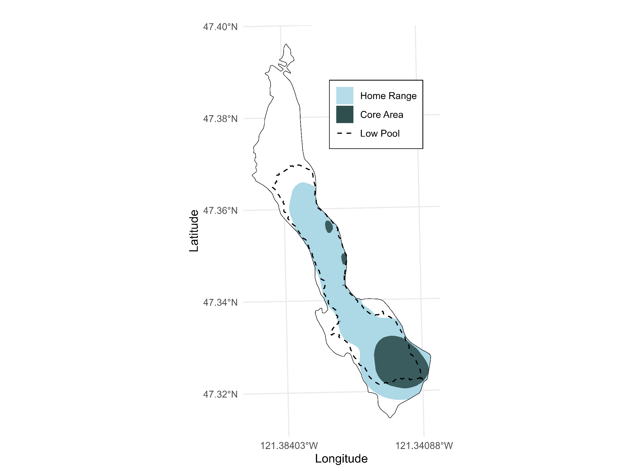

Figure 26. Population-level 50% (Core Area) and 95% (Home Range) Kernel utilization distributions for Bull Trout in Keechelus Reservoir from May to December.

**Bull Trout Entrainment at Keechelus Dam**

From their release on July 9 to the last download on December 4, entrainment probability of La Salle Bull Trout was 0.227 (95% CRI: 0.035 - 0.522) and survival probability was 0.665 (95% CRI: 0.368 - 0.918). We estimated a detection probability of 99.4% in Keechelus Reservoir and 79.3% at the PIT antenna (KCH) below Keechelus Dam. No detections were recorded on the Easton Reservoir receiver.

Because the current PIT array downstream of Keechelus Dam has been in operation for just over a year, it remains unclear whether some detections in 2024 represent newly entrained fish or individuals that were entrained in previous years. However, five acoustically tagged fish released in 2024 were detected in the stilling basin, confirming entrainment this year between July 18 and December 31. Time between the last acoustic detection in the reservoir and the first PIT detection downstream of the dam for entrained fish ranged from 2 hours to 7 days, indicating some may linger in the outlet channel—upstream of the antenna site —before being detected. No acoustically tagged fish were detected in Gold Creek in 2024 following release, including Bull Trout from trap and haul.

Six Bull Trout were detected in lower Gold Creek (G90) before their entrainment, and one fish was captured below Keechelus Dam twice in 2024, confirming that at least the second entrainment occurred in 2024. Furthermore, the first two unique fish detected in 2024 had also been recorded in 2023, indicating that these individuals were entrained prior to 2024, though the exact timing of their initial entrainment remains unknown. These were the only two fish detected both prior to and in 2024. In total, 12 of the 22 fish detected this year were entrained in 2024, while 2 were entrained at least by late 2023 (Figure 27).

Trap and haul fish detected on the array were entrained at least twice—once when originally captured and tagged, and again after being transported above the dam and subsequently re-entraining. Two bull trout with adipose clips but no PIT tags were captured in 2024, likely La Salle origin fish that had shed their tags, further limiting our ability to accurately assess entrainment.

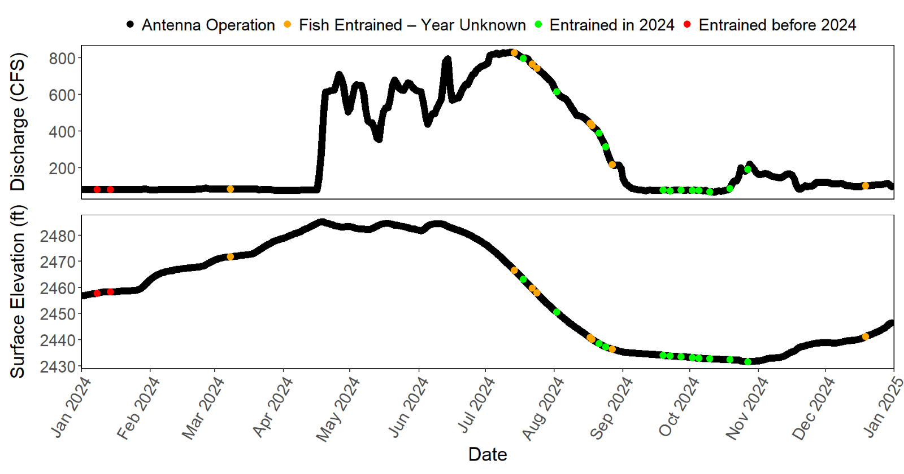

Figure 27. Seasonal timing of first PIT detections of Bull Trout in the Keechelus Dam stilling basin in 2024, shown in relation to discharge (top panel) and surface elevation (bottom panel). Each dot represents the first detection of an individual Bull Trout tagged in 2024: red dots indicate fish entrained before 2024 (detected in both 2023 and 2024), green dots indicate fish entrained in 2024 (detected above the dam before appearing below), and orange dots indicate fish of uncertain origin (potentially entrained in 2024 or entrained before 2024 but returned to stilling basin).

## Fish Movements and Water Temperature

### Upper Yakima River Basin

At our upper Gold Creek array (UGC1, UGC2), we detected one Bull Trout between June 30 and July 8 (Table B1). This fish was reared at La Salle. Mean daily water temperatures ranged from a high of 12.7°C on August 16 to a low of 0°C in January (Figure 9).

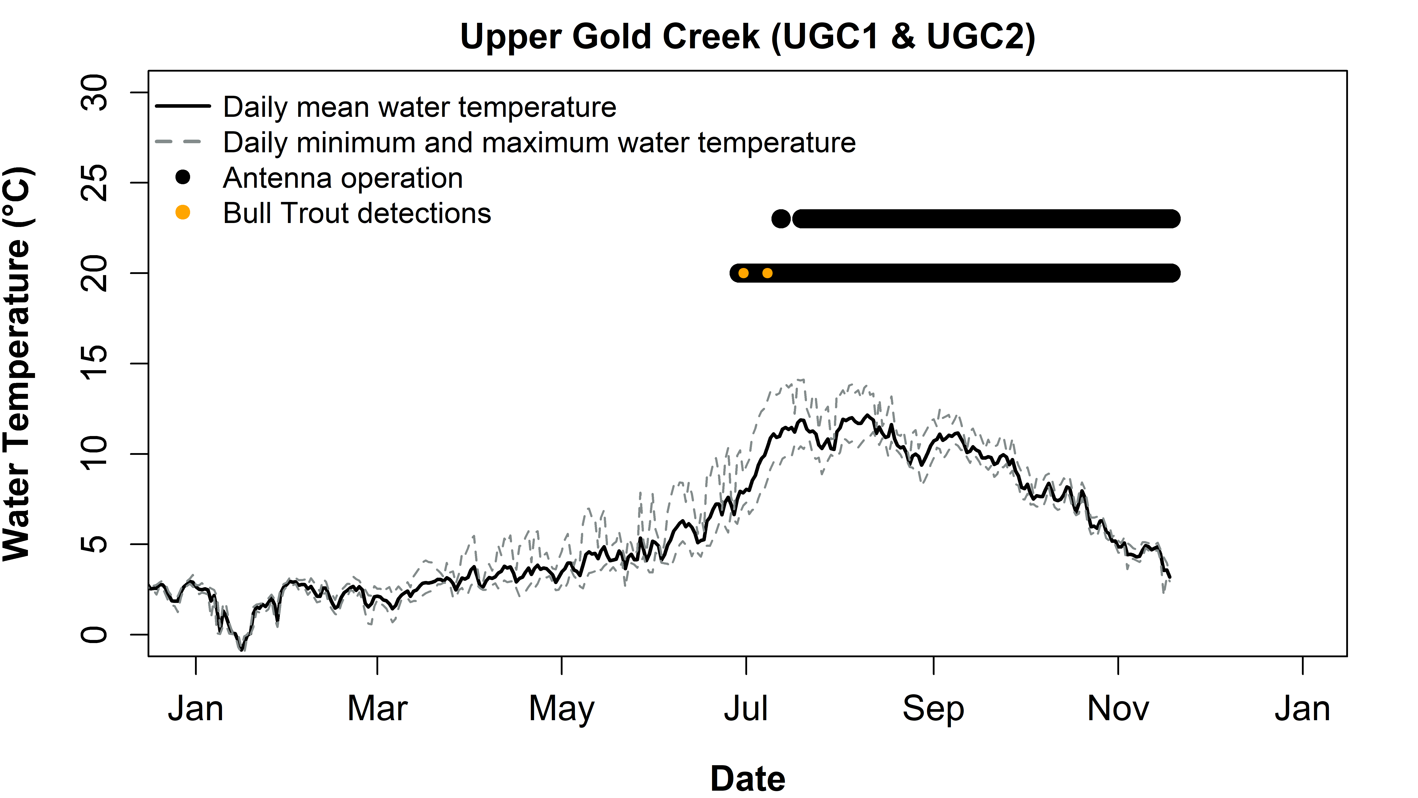

Figure 9. Seasonal change in water temperature, antenna operation, and detections of PIT-tagged Bull Trout at the upper Gold Creek array (UGC1, UGC2) during 2024. The top bar indicates UGC1 (upstream antenna) operation, and the bottom bar indicates UGC2 (downstream antenna) operation.

Downstream at our lower Gold Creek site (G90), 19 Bull Trout were detected (Table B2). Twelve of these detected fish were reared at La Salle, of which three were released in 2020, five in 2021, two in 2022, and one 2023. However, one fish (3DD.007749F0E0) that was recaptured below Keechelus, had shed its original PIT tag (identified via adipose fin clip) and therefore the original release date could not be verified. Two of the detected fish were tagged by WDFW during their rescue operations in 2023. Five of the fish detected were captured and tagged during trap and haul operations, of which three were released in 2021, and two in 2023. Bull Trout were detected at this site from March 17 to October 26. The Bull Trout that was detected at the upper Gold Creek array was first detected on June 30 and then again on July 8. It then moved downstream and was detected at G90 on July 9. Mean daily water temperatures at G90 ranged from 16°C on August 16 to 1.0°C on January 28 (Figure 10). The temperature logger did not collect data from November 1 to December 31.

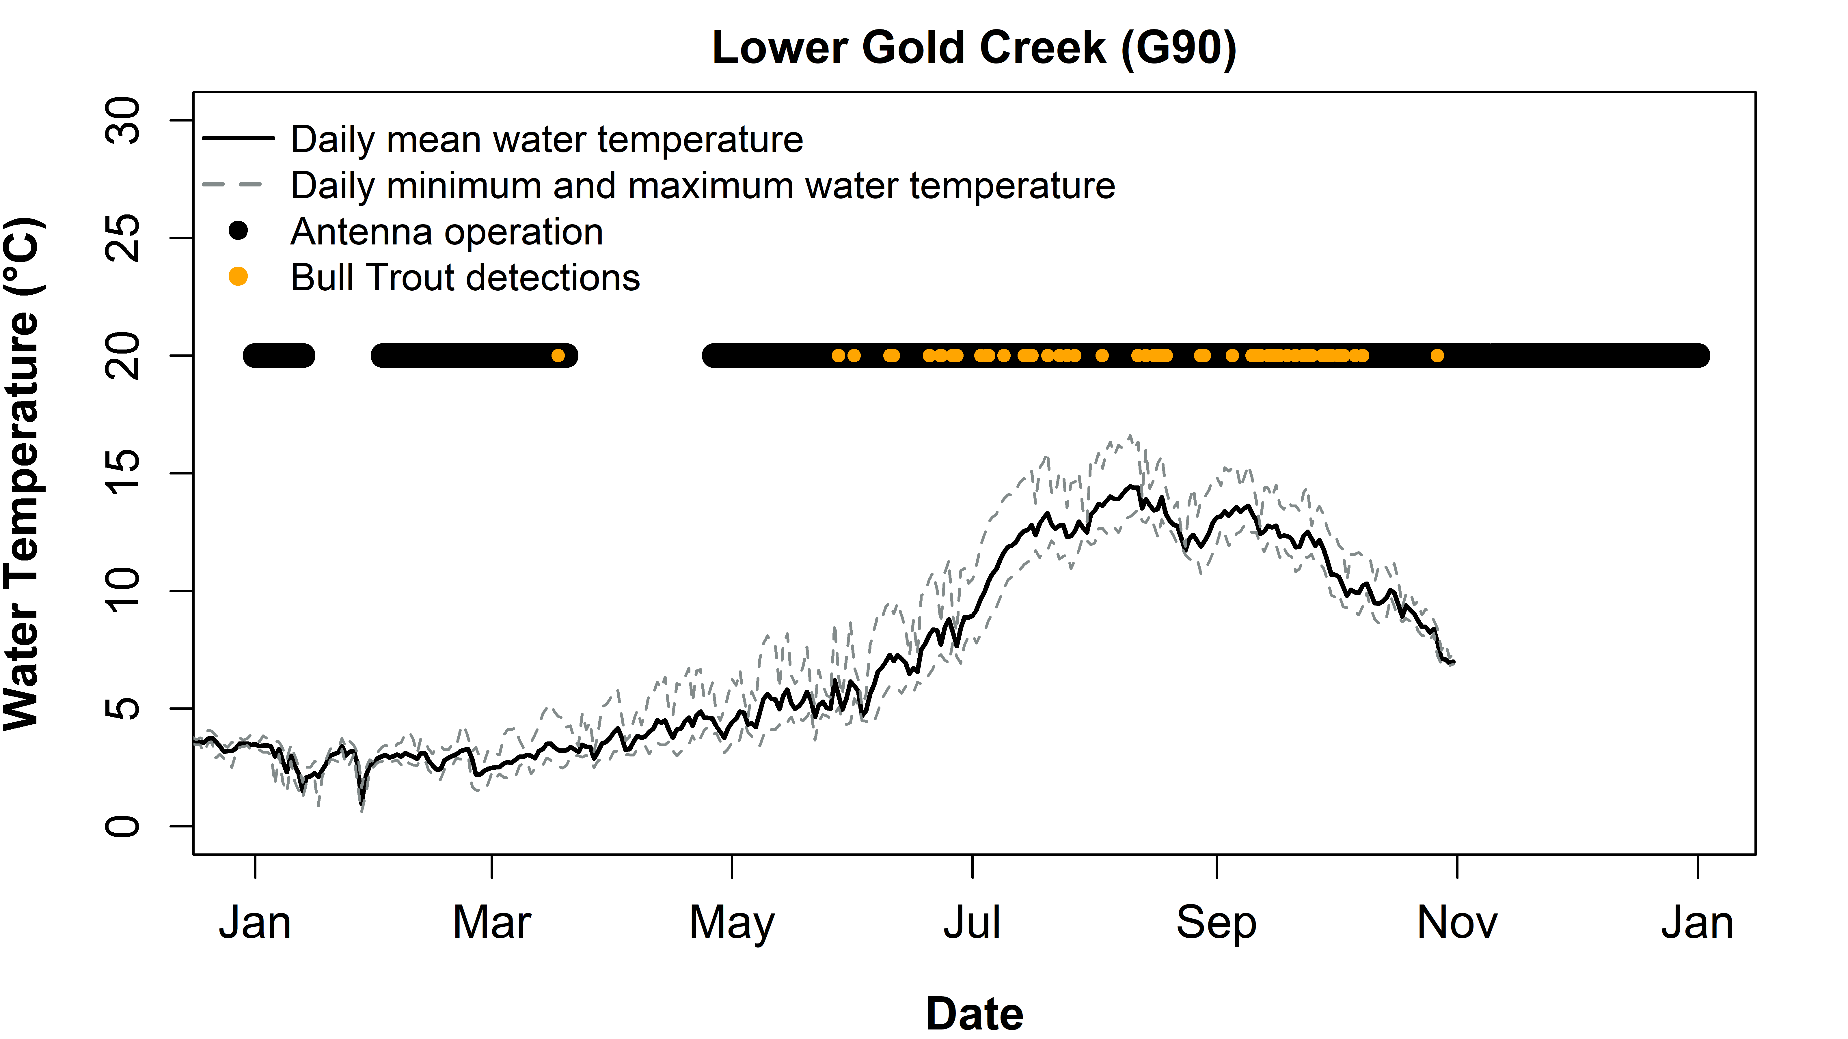

Figure 10. Seasonal change in water temperature, antenna operation, and detections of PIT-tagged Bull Trout at the lower Gold Creek antenna (G90) during 2024.

No fish were detected entering Gold Creek Pond in 2024. The site was operated from September 20 to November 18, when the stream became disconnected from the reservoir. The mean daily water temperature at Gold Creek Pond ranged from 3.3°C on February 19 to 17°C on August 8 (Figure 11).

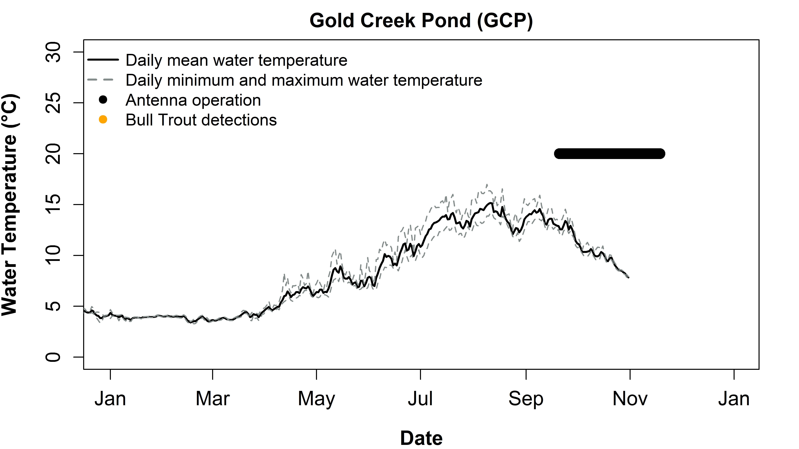

Figure 11. Seasonal change in water temperature, antenna operation, and detections of PIT-tagged Bull Trout at the Gold Creek Pond Outlet antenna (GCP) during 2024.

No fish were detected in Cold Creek in 2024. The sites were operated from May 21 to August 28, when the stream became disconnected from the reservoir. The mean daily water temperature at COLD ranged from 5.1°C on May 21 to 16.0°C on August 3 (Figure 12).

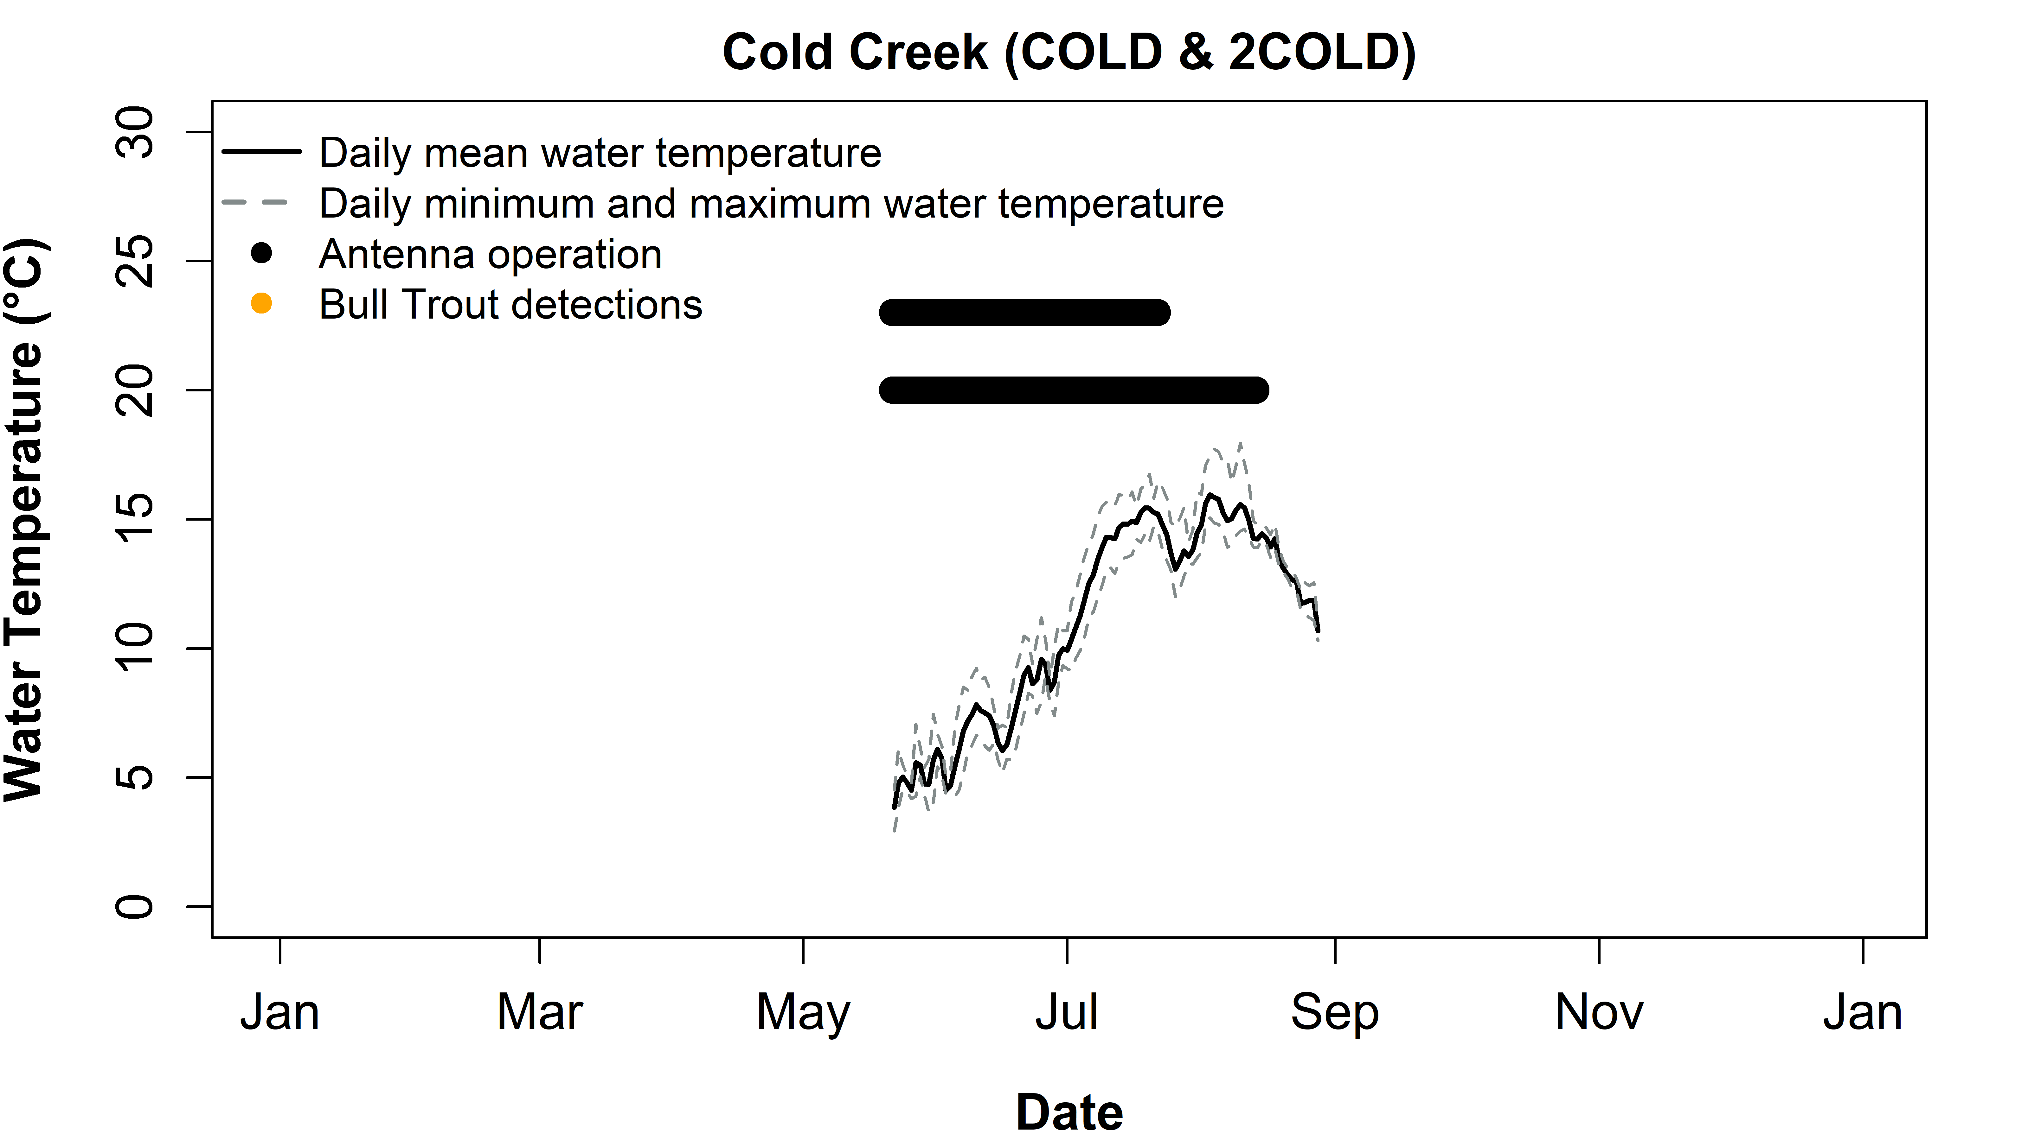

Figure 12. Seasonal change in water temperature, antenna operation, and detections of PIT-tagged Bull Trout at the upstream (COLD) and downstream (2COLD) sites in Cold Creek during 2024. Note that temperature was collected at the upstream site.

Below Keechelus Dam, we detected 22 Bull Trout on the Keechelus Outlet Channel array (KCH1, KCH2, KCH3) between January 7 and December 31 (Figure 13, Table B4). Three of these fish were tagged during trap and haul below Keechelus Dam in 2023, one fish was released in Gold Creek during a 2019 rescue effort, and the other 18 fish were reared at La Salle: two released in 2020, six in 2021, one in 2022, four in 2023, and five in 2024. Eight of the fish that were detected on the array were recaptured and transported above the dam. Water temperature was only collected from December 4 to 31, ranging from 3.3 to 4.7°C.

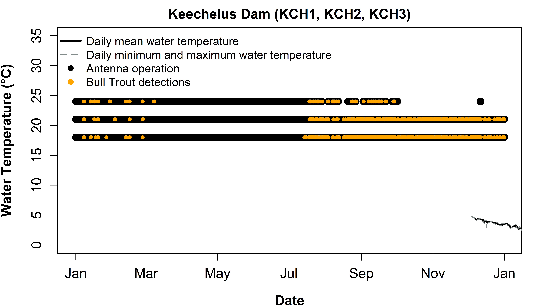

Figure 13. Seasonal change in water temperature, antenna operation, and detections of PIT-tagged Bull Trout at the Keechelus Dam array (KCH1-3) during 2024

Three Bull Trout were detected at the upstream antenna in the upper Kachess River (KR1), all of which were La Salle reared and released in previous years: one in 2020 and two in 2022. Bull Trout were detected at this site from November 15 to November 22 (Figure 14). None of the fish detected at this site were detected at the downstream antennas in the upper Kachess River (KACL, KACL2). The single fish tagged in 2020 (3DD.00774A62B7) was detected in Box Canyon Creek on November 5 and later detected at KR1 on November 15. Mean daily water temperature at the upstream Kachess River site ranged from 13.2°C on August 3 to 0°C on January 13. Temperature data was not collected after October 8.

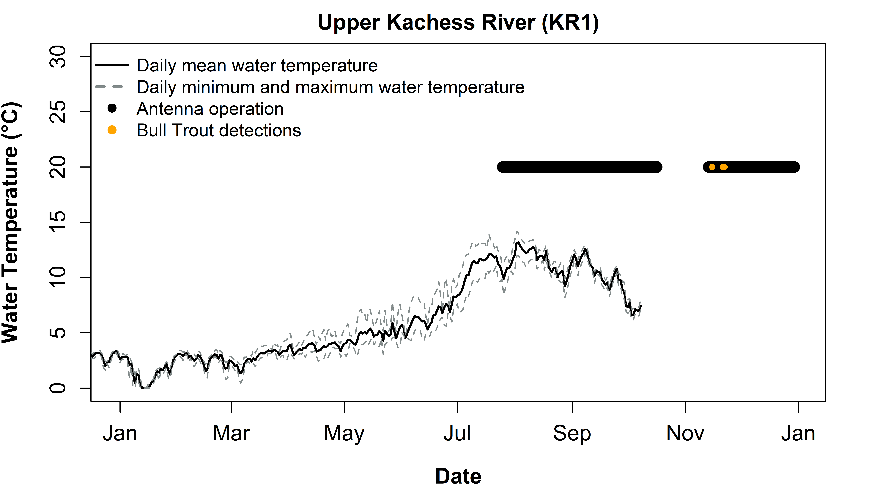

Figure 14. Seasonal change in water temperature, antenna operation, and detections of PIT-tagged Bull Trout at the upstream array on the upper Kachess River (KR1, KR2) during 2024. The top bar indicates KR1 (upstream antenna) operation, and the bottom bar indicates KR2 (downstream antenna) operation.

Eight Bull Trout were detected at the downstream site on the upper Kachess River (KACL, KACL2). All were La Salle reared fish of which one was released in 2020, two in 2021 and five in 2022. All fish were first detected at the site on October 27 or 28, shortly after the river rewatered, except for one fish (3DD.003D481194) which was detected on November 14. Mean daily water temperature ranged from 11.5°C on July 10 to 0°C on January 16 but the riverbed was mostly dry from July 13 through October 25 (Figure 15). Intermittent rewetting may have occurred during this period but likely did not result in passable conditions until late October.

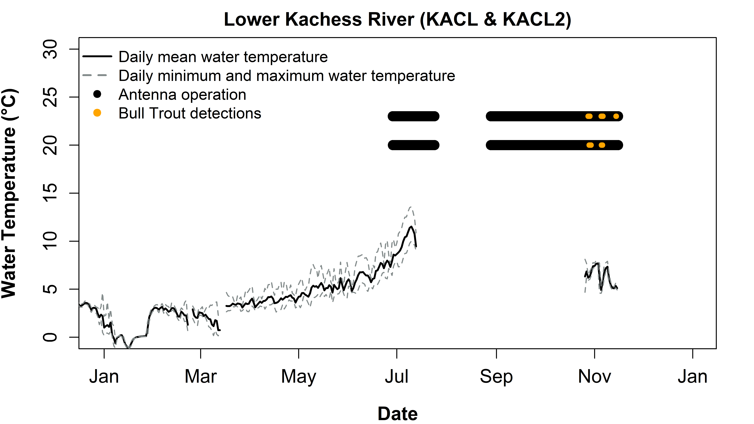

Figure 15. Seasonal change in water temperature, antenna operation, and detections of PIT-tagged Bull Trout at the downstream array on the upper Kachess River (KACL and KACL2) during 2023. The top bar indicates KACL1 (upstream antenna) operation and the bottom bar indicates KACL2 (downstream antenna) operation.

Of the twenty-one Bull Trout detected at the Box Canyon Creek array (BOX1, BOX2), two released in 2024 were detected on July 10 and July 18, while the remaining fish were detected between October 8 and November 5. (Figure 16). Twenty of the fish were rescued from the upper Kachess River and reared at La Salle; one of the fish was released in 2020, seven were released in 2021- two of which were acoustically tagged by USFWS, ten were released in 2022- five of which were acoustically tagged by USFWS, and two were released in 2024 (Table B7). The other fish was captured in 2023 below Keechelus Dam and released into Little Kachess Lake.

We detected five Bull Trout at the Box Canyon Creek flume (BOX3) from September 26 to October 11. All except one fish (3DD.003D481171) were later detected at the Box Canyon Creek array (BOX1, BOX2).

All 21 fish detected in Box Canyon Creek (BOX1 - BOX3) were assumed to be of Kachess River origin. Seven Bull Trout that were detected in Box Canyon Creek were later detected in the Kachess River. One of these Bull trout (3DD.00774A62B7) was initially detected at BOX2 on November 5, later was detected at KR1 on November 15, but was not detected at KACL nor KACL2. Six Bull Trout moved from Box Canyon Creek to KACL or KACL2. Among those, two later re-entered Box Canyon Creek. One fish (3DD.003D59D153) was first recorded at BOX1 and BOX2 on October 21, then detected at KACL on October 28 and 29, and subsequently returned to Box Canyon Creek on November 2, where it remained until November 5. Similarly, fish 3DD.003D4811A9 was initially detected at BOX3 on October 5, followed by detections at BOX1 and BOX2 on October 21 and at NARN on October 22; it was later observed at KACL and KACL2 on October 28 and 29, re-entered Box Canyon Creek on October 30, and finally returned to the Kachess River with detections at KACL and KACL2 on November 5 and 6. Mean daily water temperature at the Box Canyon Creek array ranged from 14.7°C on August 3 to 0°C on January 12 (Figure 16). Temperature data was not collected past November 5.

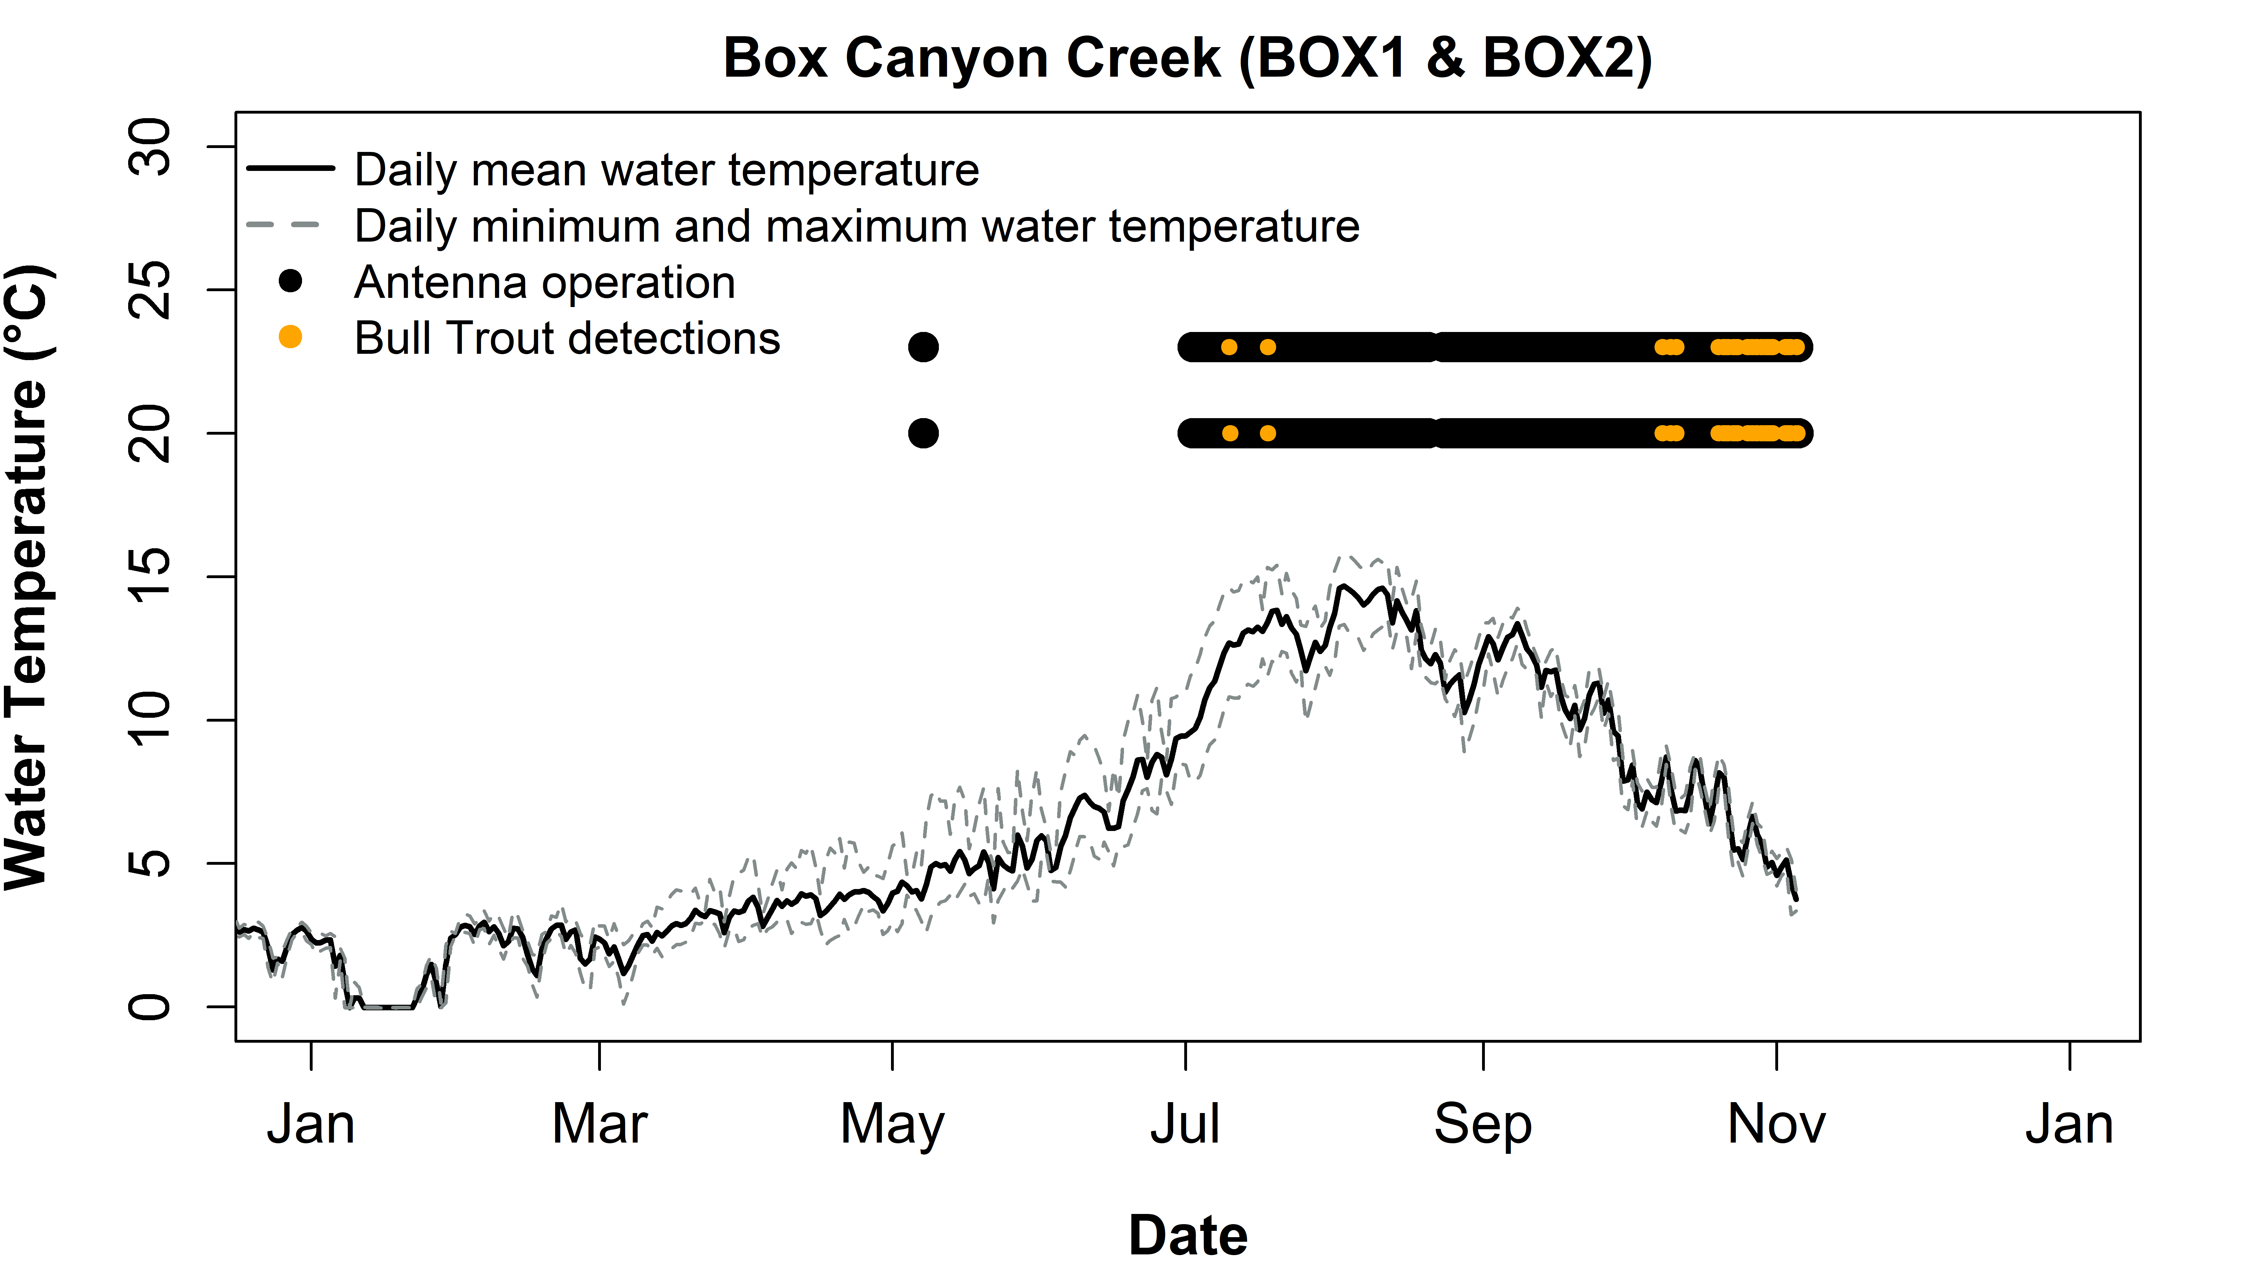

Figure 16. Seasonal change in water temperature, antenna operation, and detections of PIT-tagged Bull Trout at the Box Canyon Creek array (BOX1, BOX2) during 2023. The top bar indicates BOX1 (upstream antenna) operation, and the bottom bar indicates BOX2 (downstream antenna) operation.

Eight fish were detected at The Narrows submersible antenna (NARN) between September 22 and October 27. All fish were reared at La Salle with one released in 2020, two released in 2021, and five released in 2020, three of which were acoustically tagged by USFWS. Only one fish (3DD.003D5A4443) was detected solely at NARN. Of the other seven fish detected at NARN, three were detected at Box Canyon Creek, one was detected at the Kachess River, and three were detected at both Box Canyon Creek and the Kachess River.

### Naches River Basin

In total, we detected 31 Bull Trout at the upper North Fork Tieton River antenna site (UPNFT; Figure 17) and 32 Bull Trout at the lower North Fork Tieton River antenna site (NFT; Figure 18) in 2024. Detections at both sites include transports from 2019-2024 (Table 5). The one fish detected at the lower site but not at the upper site was transported in 2020. Of the fish detected at UPNFT, 9 were transported above Clear Creek Dam in 2024, 35% of the Clear Creek Dam transports in 2024. Bull Trout were detected at the NFT site from June 22 to October 18 (Table C2). During this time, the mean daily water temperature ranged from 5.3 to 13.0 °C with a maximum of 15.5 °C on August 4 (Figure 18). At the UPNFT site, Bull Trout were detected from July 3 to October 17 (Table C1). During this time, the mean daily water temperature ranged from 5.3 to 11.9 °C with a maximum of 14.2 °C on August 2 (Figure 17).

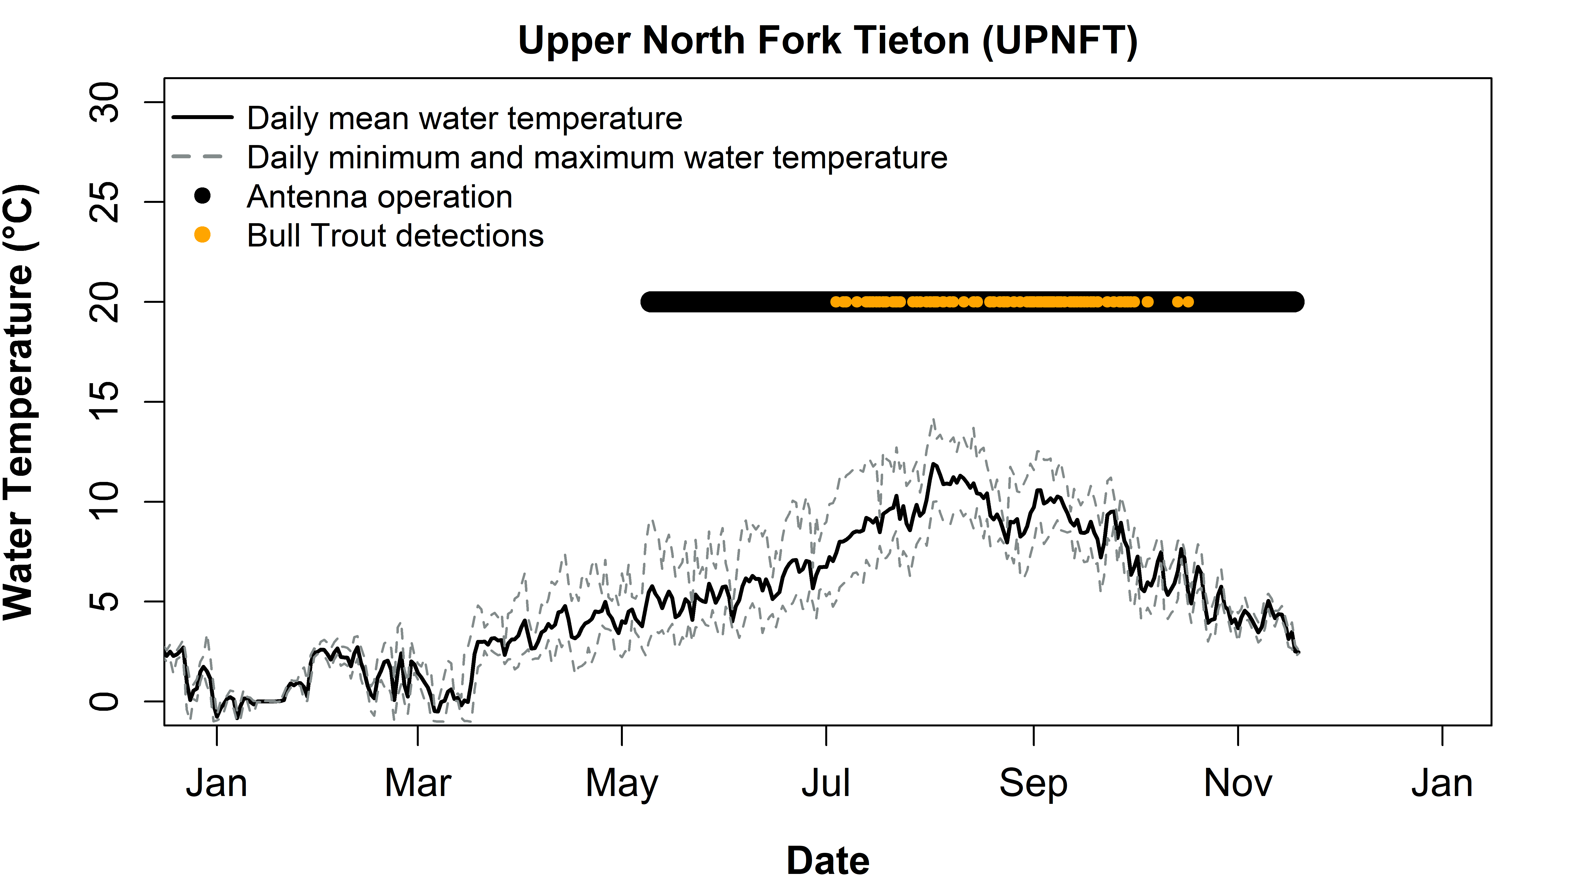

Figure 17. Seasonal change in water temperature, antenna operation, and detections of PIT-tagged Bull Trout at the upper North Fork Tieton River antenna (UPNFT) during 2024.

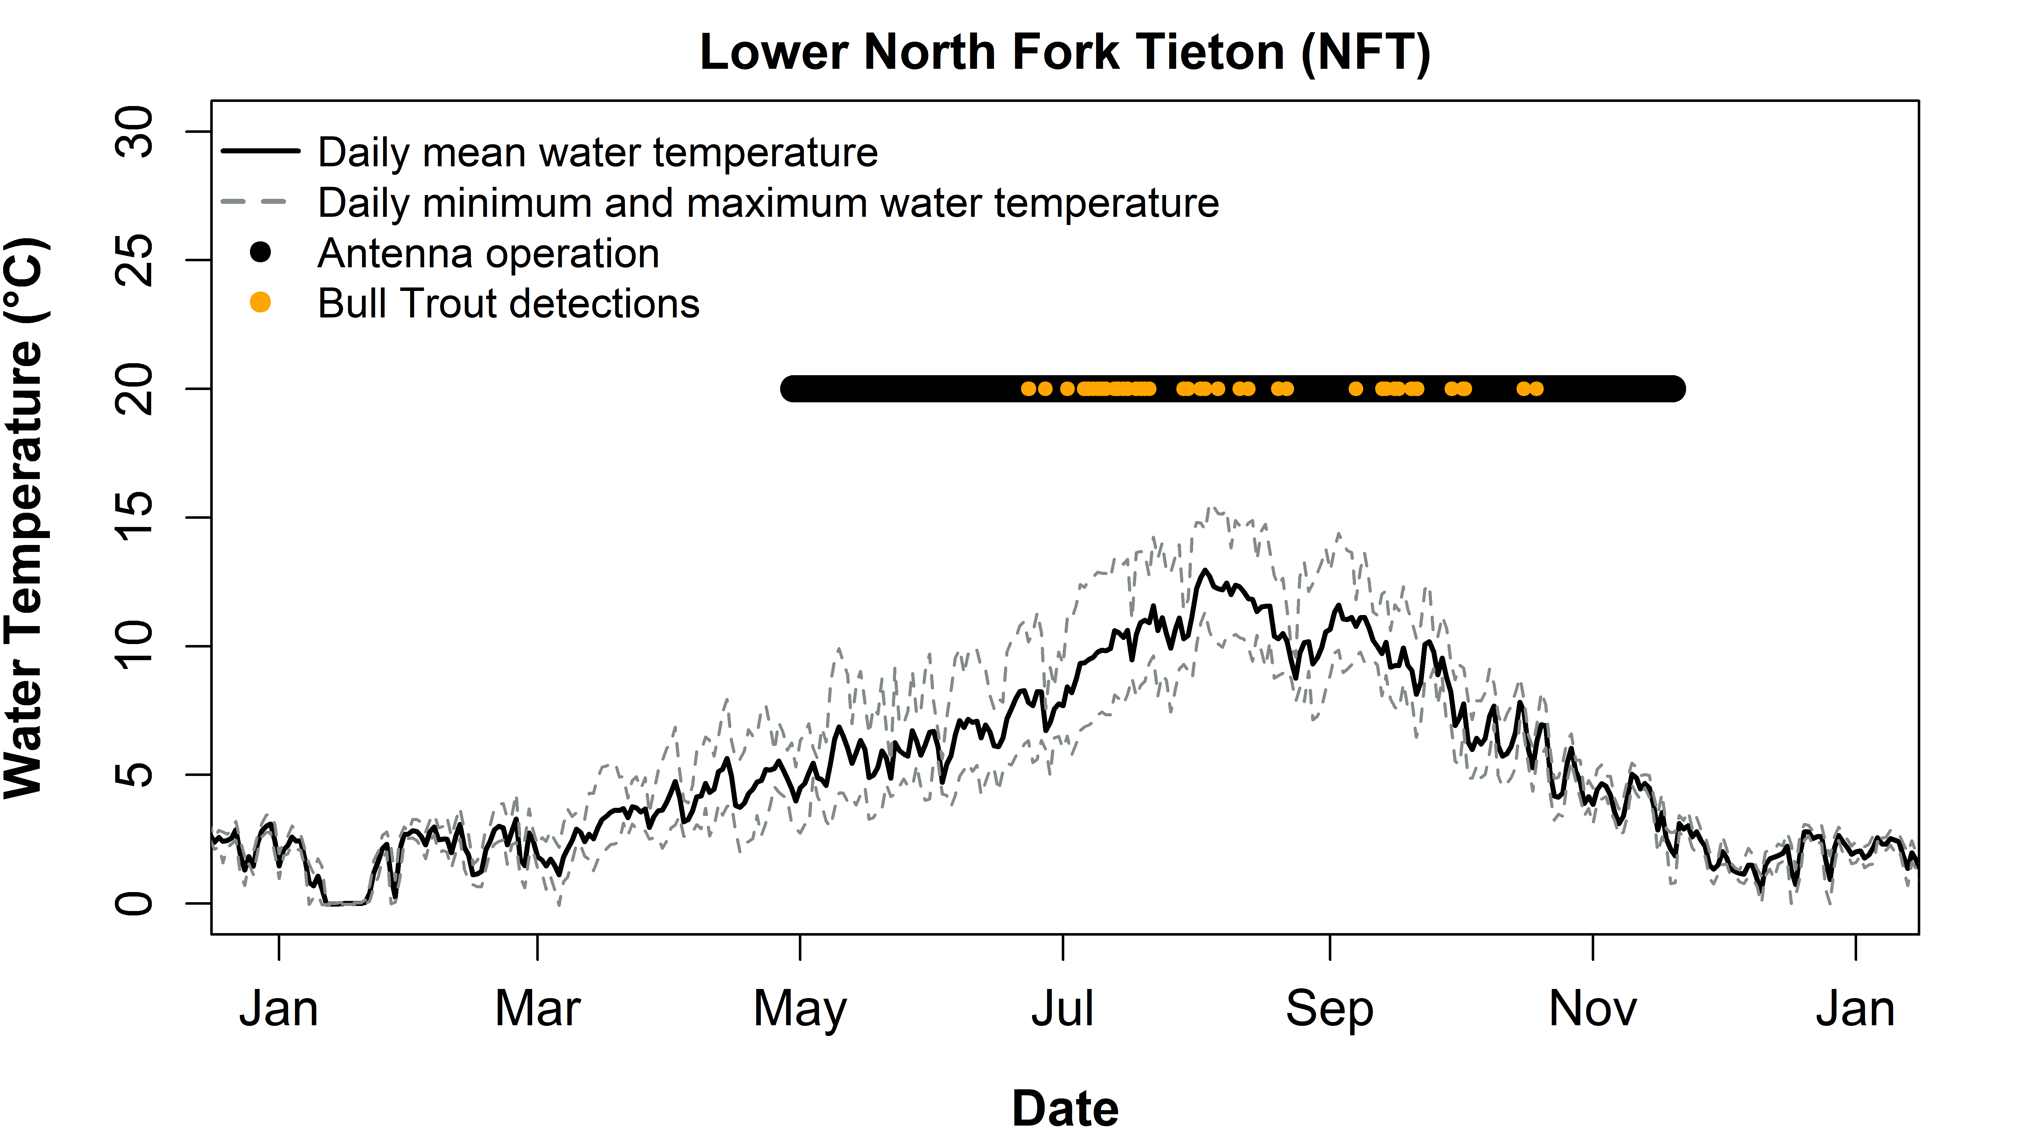

Figure 18. Seasonal change in water temperature, antenna operation, and detections of PIT-tagged Bull Trout at the lower North Fork Tieton River antenna (NFT) during 2024.

Table 5. Number of Bull Trout transported to Clear Creek Reservoir by year, and the number of those Bull Trout that were detected at the North Fork Tieton River antenna sites in 2024.

|  |  |  |  |
| --- | --- | --- | --- |
| Year Tagged | Total Number Transported (Recaptures Inclusive) | Number detected at the lower North Fork Tieton River antenna in 2024 | Number detected at the upper North Fork Tieton River antenna in 2024 |
| 2016 | 27# | 0 | 0 |
| 2017 | 15 | 0 | 0 |
| 2018 | 22(2) | 0 | 0 |
| 2019 | 19(3) | 1 | 1 |
| 2020 | 3 | 1 | 0 |
| 2021 | 15 | 4 | 4 |
| 2022 | 8 | 3 | 3 |
| 2023 | 25(2) | 14 | 14 |
| 2024 | 20 | 9 | 9 |
| **Total** | **154(7)** | **32** | **31** |

# includes 12 Indian Creek and South Fork Tieton River-origin fish that were transported

We detected six Bull Trout at the upper Clear Creek Dam fish ladder site (ULD) between August 10 and November 19, indicating that some fish may have exited Clear Creek Reservoir during that time (Table C3). One of the detected fish was transported in 2022, four were transported in 2023, and one in 2024. Of the six fish detected in the ladder, three were detected exiting the lower North Fork Tieton River site, two on September 21 and one on October 2, prior to being detected at the fish ladder on September 22, September 26, and October 5, respectively. One fish was detected at the upper North Fork Tieton River site on September 24 prior to being detected at the fish ladder on September 27. However, two fish were detected traveling up the ladder in 2024. The first fish was of North Fork Tieton River origin and detected at OCH August 9, then ULD on August 10, then NFT August 13, and making up to UPNFT on August 15, where it spent roughly a month before being detected at UPNFT and then NFT on September 19, indicating that this fish probably spawned. The second fish was the only fish detected at the lower Clear Creek Dam fish ladder site (LLD). This fish was of South Fork Tieton River origin and released downstream of the stilling basin. It was detected at OCH, LLD, and ULD on November 19. The mean daily water temperature in the Clear Creek Dam fish ladder during the time when Bull Trout were present ranged from 18.9°C on August 10 to 11.1°C on October 5. Temperature data was not available for the November 19 detection (Figure 19).

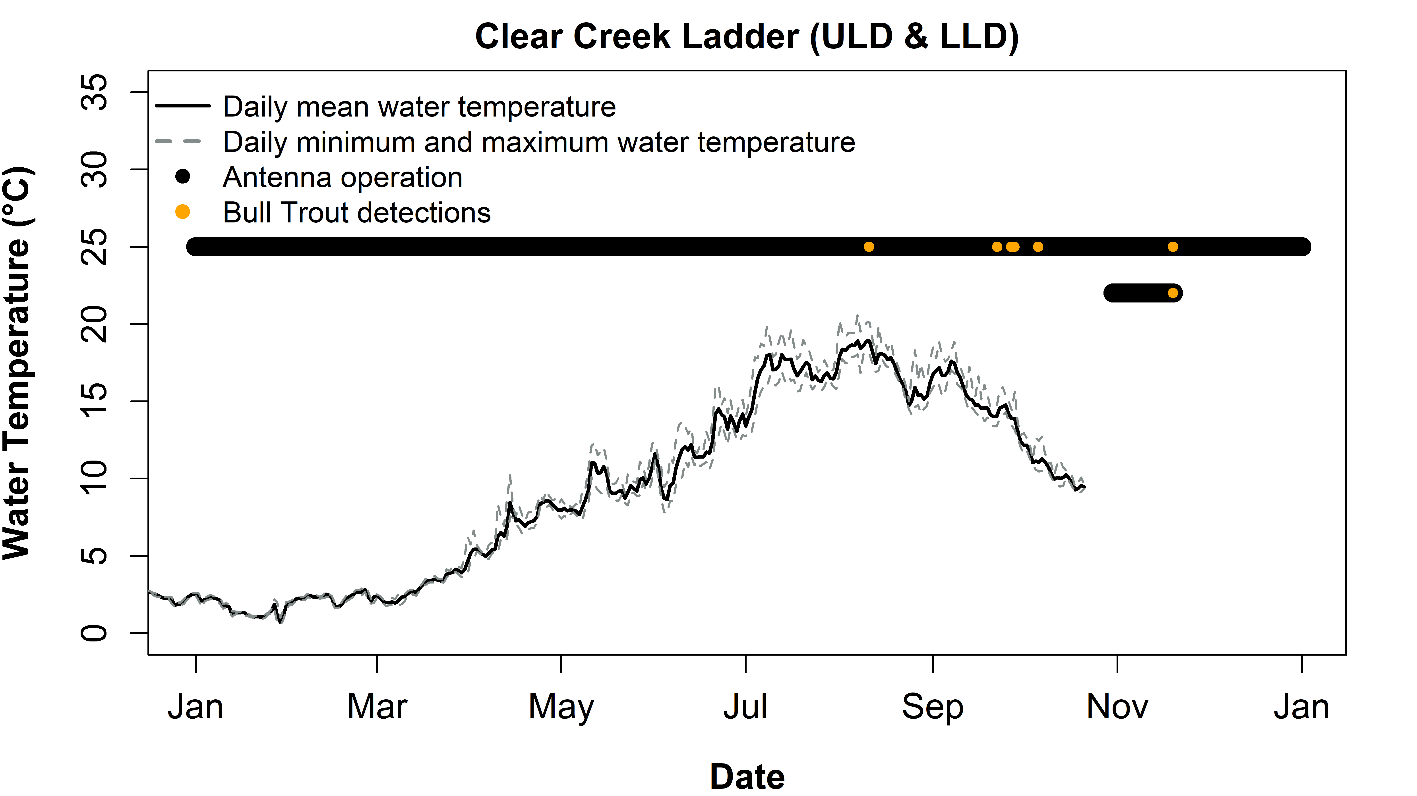

Figure 19. Seasonal change in water temperature, antenna operation, and detections of PIT-tagged Bull Trout at the upper ladder antenna (ULD) and lower ladder antenna (LLD) of the Clear Creek Dam spillway during 2024. The top bar indicates ULD (upstream site) operation, and the bottom bar indicates LLD (downstream site) operation. Note that temperature was collected within the ladder, between the two antenna sites.

At the Clear Creek Dam outlet channel site, we detected 56 Bull Trout between June 10 and November 19 (Figure 20). Forty-eight of these fish were Indian Creek- or South Fork Tieton River-origin fish, collected in the Clear Creek Dam stilling basin and released downstream. Of the Indian Creek fish, one was tagged in 2022, five were tagged in 2023, and twenty-six were tagged in 2024. Of the South Fork Tieton River-origin fish detected at OCH one was tagged in 2023, and fifteen were tagged in 2024. The seven North Fork Tieton River-origin Bull Trout detected below Clear Creek Dam consisted of one fish tagged in 2023 and six that were tagged in 2024. The six North Fork Tieton River-origin fish tagged and released above Clear Creek Dam in 2024 were later detected at OCH from August 28 to November 5. Because they were not detected at either ladder site, they likely entrained through the dam or the spillway. The fish released in 2023 is the same fish that ascended the ladder in August to presumably spawn. It was first detected at ULD in November of 2023, being detected at OCH on June 14, July 9, and August 9. An additional Bull Trout was detected and recaptured at OCH, however this fish was not tagged by us and therefore we cannot confirm its origin.

When Bull Trout were present at this site, mean daily water temperature ranged from 3.8 to 13.3°C with a maximum of 13.7°C on August 12 (Figure 20).

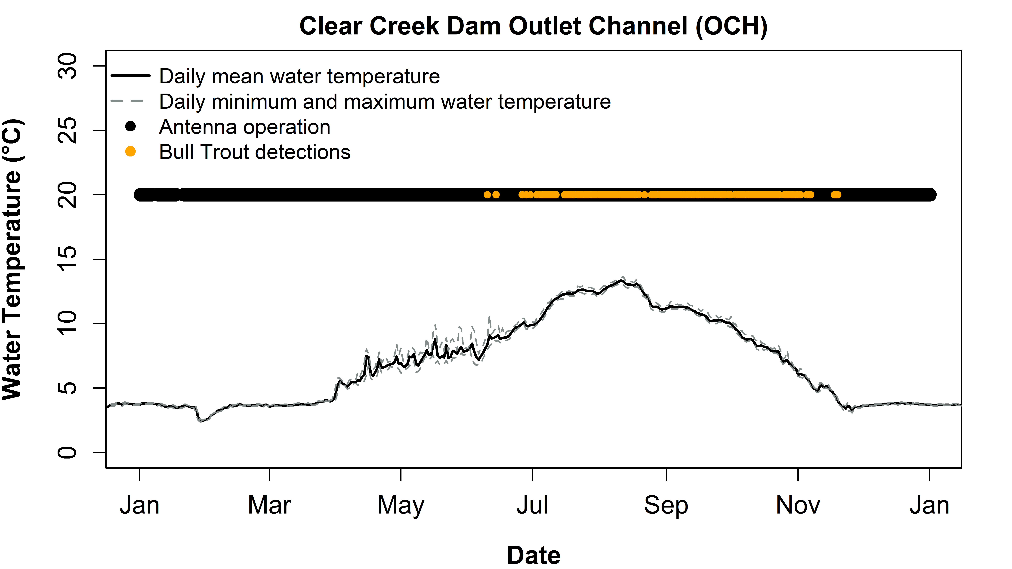

Figure 20. Seasonal change in water temperature, antenna operation, and detections of PIT-tagged Bull Trout at the Clear Creek Dam Outlet Channel antenna (OCH) during 2024.

In 2024 we detected 27 Indian Creek-origin Bull Trout at our Indian Creek array (IND1, IND2) between June 10 and October 17 (Figure 21). All fish were previously tagged and released below Clear Creek Dam, including 2 in 2021, 1 in 2022, 14 in 2023, and 10 in 2024 (Table C5). Ten of the thirty-three Indian Creek-origin Bull Trout captured at Clear Creek Dam in 2024 were subsequently detected in Indian Creek 16 to 49 days after they were captured at Clear Creek Dam. While Bull Trout were present at this site, mean daily water temperature ranged from 6.2°C to 10.0°C with a maximum of 13.5°C on July 14.

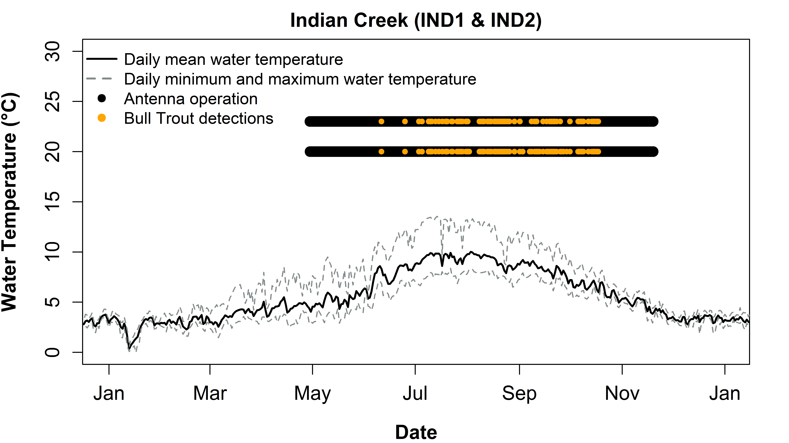

Figure 21. Seasonal change in water temperature, antenna operation, and detections of PIT-tagged Bull Trout at the Indian Creek array (IND1, IND2) during 2024. The top bar indicates IND1 (upstream antenna) operation, and the bottom bar indicates IND2 (downstream antenna) operation.

In 2024 we detected nine Bull Trout at the lower South Fork Tieton River antenna site (LSFT; Figure 22) and five at the upper South Fork Tieton River antenna site (SFT; Figure 23). All fish detected at the upper site were also detected at the lower site. All were South Fork Tieton River-origin fish except one (3DD.003D4811D4) which was of Indian Creek-origin. Most South Fork Tieton River-origin fish were originally captured and released downstream of Clear Creek Dam: six in 2023, and one in 2024. However, one fish was captured during trap and haul operations in 2020 below Tieton Dam and released directly into the South Fork Tieton River. The other ten South Fork Tieton River-origin fish captured during 2024 trap and haul below Clear Creek Dam were not detected in the South Fork Tieton River in 2024. The Indian Creek-origin fish was detected at both the LSFT and SFT sites from July 17 until August 21 and was then detected on the Indian Creek array from August 25 to September 21.

At the LSFT antenna site, Bull Trout were detected from May 9 to September 25. During this time, the mean daily water temperature ranged from 7.1 to 16.6°C with a maximum of 20.1°C on August 4 (Figure 22). Bull Trout were detected at the SFT antenna site from July 10 to September 24 (Figure 23). However, this site experienced a lapse in operations and likely missed some fish detections. During this time, the mean daily water temperature ranged from 10.0 to 14.7°C with a maximum of 17.9°C on August 1. Temperature data was not collected after August 23.

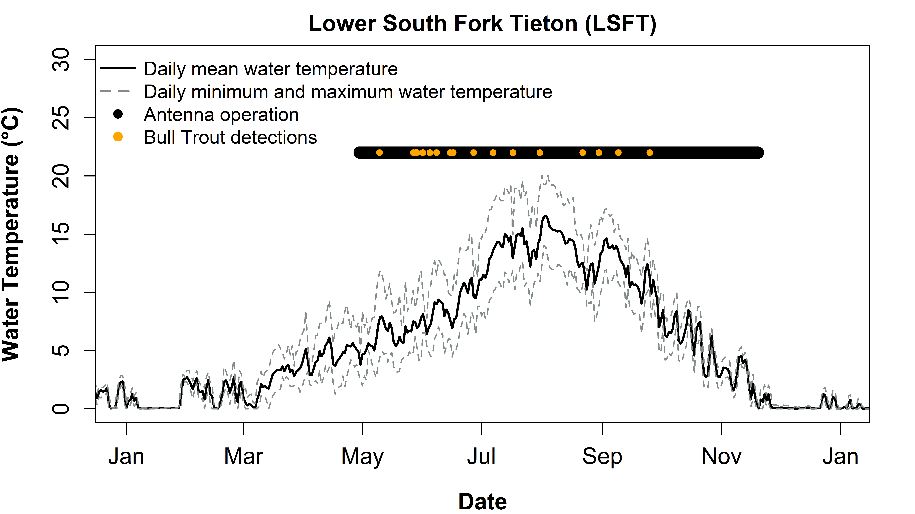

Figure 22. Seasonal change in water temperature, antenna operation, and detections of PIT-tagged Bull Trout at the lower South Fork Tieton River antenna (LSFT) during 2024.

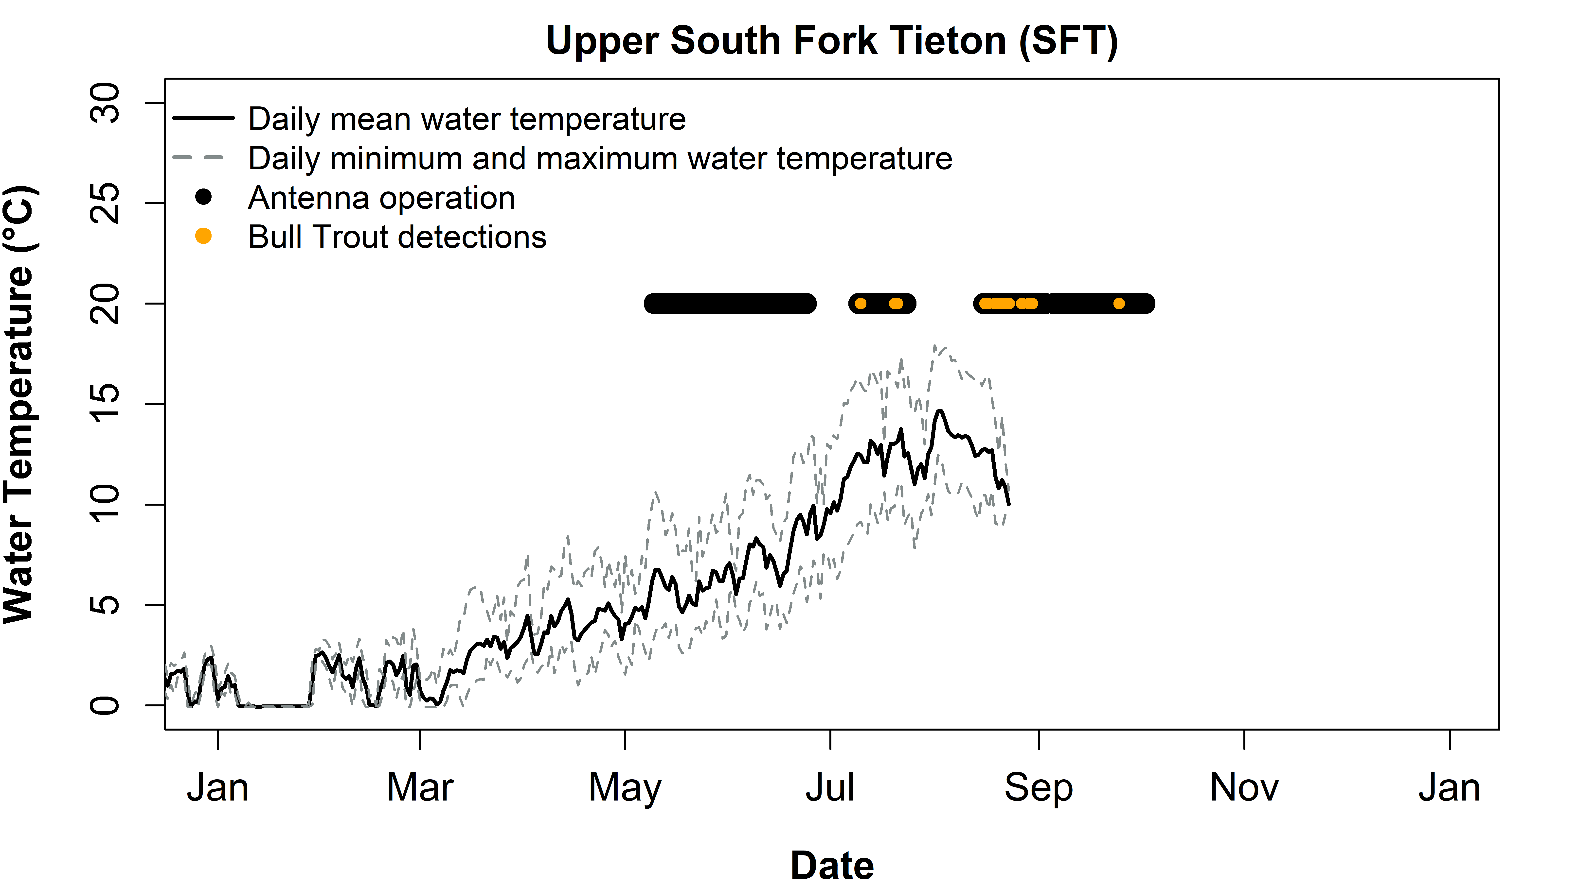

Figure 23. Seasonal change in water temperature, antenna operation, and detections of PIT-tagged Bull Trout at the upper South Fork Tieton River antenna (SFT) during 2024.

## Survival and Detection Probability

Survival analysis utilized detection histories of 161 North Fork Tieton River-origin individuals marked between 2012-2023 from 12 observation periods (i.e., recapture events) from 2013-2024. Mean survival probability across all study years was 63.3% (95% CRI: 56.9 – 70.3%), which is the same as the previous estimated mean survival probability for years 2013-2023 (Beebe et al. 2025). The lowest annual survival probabilities were 60.2% in 2017, 60.3% in 2021, and 60.4% in 2022 while the highest annual survival probability of 67.9% occurred in 2018. The 2024 annual survival probability was 63.6% (95% CRI: 53.3 – 73.8%), which is slightly above the mean survival probability (Figure 24). Detection probabilities (i.e., probability of recapture) were between 85.5% and 99.5% across all simulations with a grand mean detection probability of 95.3% (Figure 25).

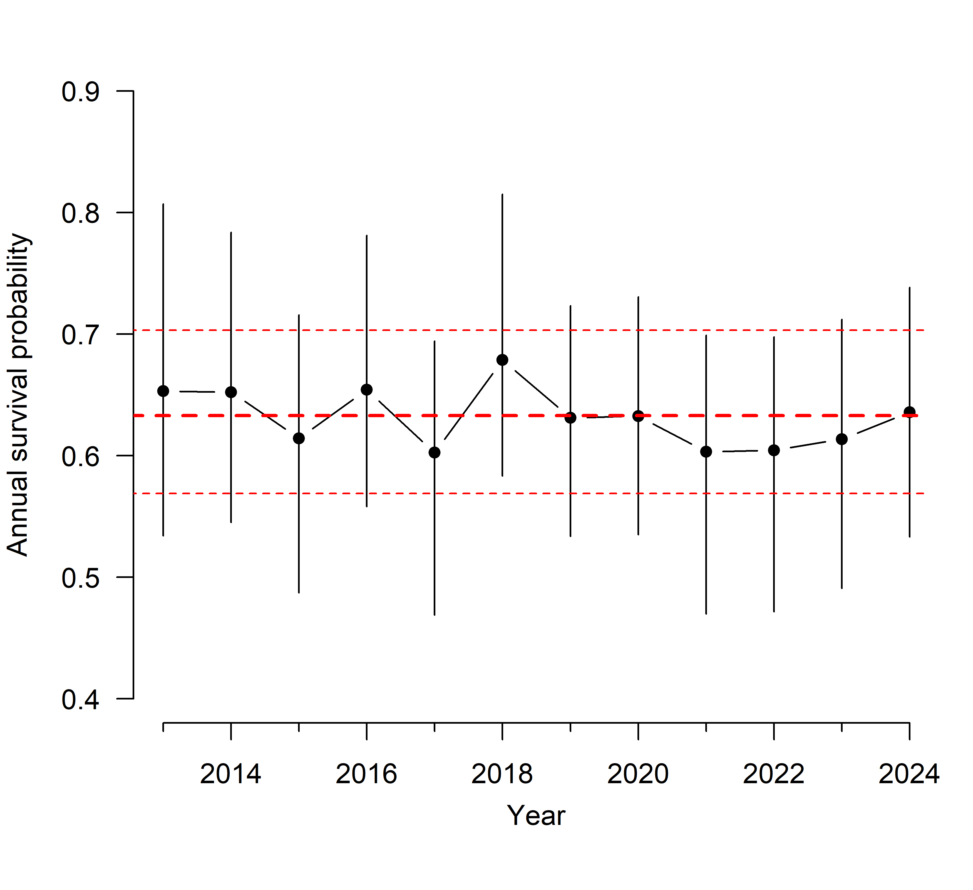

Figure 24. Annual survival probabilities of North Fork Tieton River-origin adult Bull Trout (black circles, with 95% CRIs) and mean survival (red line, with 95% CRI dotted) across study years.

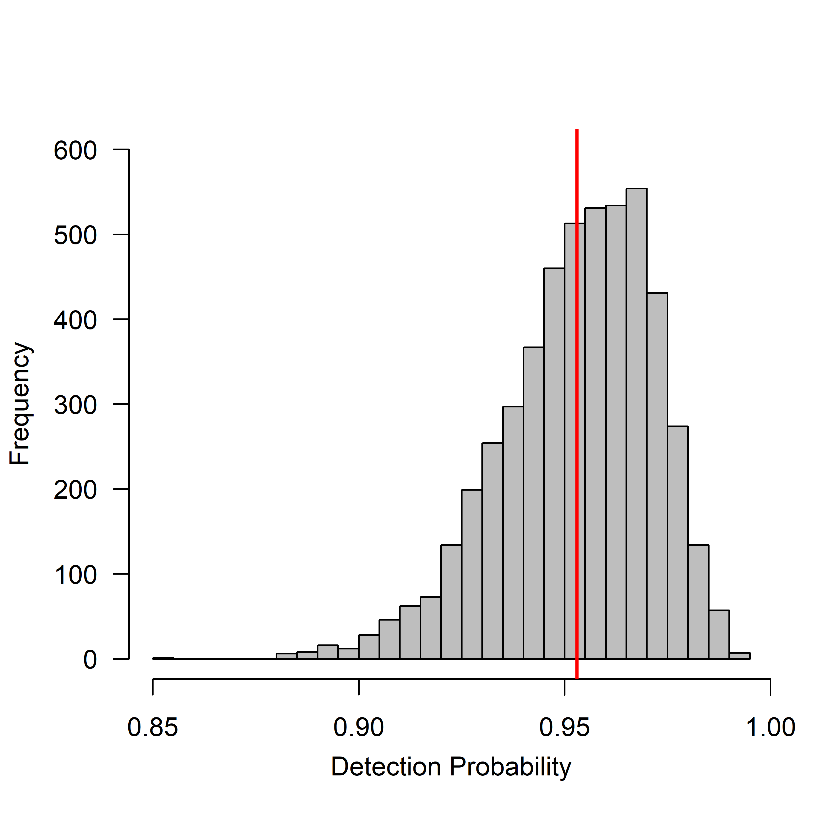

Figure 25. Posterior distribution of detection probabilities from 2013-2024. Red line indicates grand mean detection probability.

# Discussion

The Gold Creek Bull Trout population is limited both by dewatering of lower Gold Creek and entrainment at Keechelus Dam. Of the 19 fish detected at our lower Gold Creek antenna in 2024, only 1 was detected at the upstream array located upstream of the dewatering zone. This fish was detected prior to (June 30-July 8) the regular spawning period and moving downstream, indicating it could have overwintered in Gold Creek before moving downstream with spring flows. As comparison to the North Fork Tieton River that does not have dewatering issues near its mouth, 31 of the 32 fish detected at our lower antenna were also detected at the upper antenna site (Table 5). Similarly in 2023, 24 of 27 fish detected at our lower North Fork Tieton River antenna site were also detected at our upper antenna site (Beebe et al. 2025). Extensive dewatering in lower Gold Creek, downstream of the upper antenna array limits upstream migration, resulting in relatively few fish reaching the primary spawning grounds. Extensive in-stream restoration in the lower 4.8 km (3 miles) of Gold Creek is expected to begin in 2025 to alleviate dewatering.

Our data also indicated that 34 entrained Gold Creek-origin Bull Trout were either detected on our PIT antenna array below Keechelus Dam or were captured during trap and haul. Several fish entrained more than once. Although we captured and relocated 20 fish to Keechelus Reservoir (19 from below Keechelus Dam, one from below Kachess Dam), none accessed Gold Creek. At least 14 Bull Trout ultimately avoided capture and remained below Keechelus Dam. In 2025 we will continue trap and haul using the methods described here but will also deploy a picket weir trap in the Keechelus Dam outlet channel in hopes of increasing our collection numbers. This trap was previously used to collect Bull Trout in the lower North Fork Tieton River (Thomas et al. 2014). The acoustic telemetry data indicated that while Bull Trout traversed Keechelus Reservoir, they spent a disproportionate amount of time in the forebay which likely increased their entrainment probability. For La Salle implanted with acoustic tags, we estimated an entrainment probability of nearly 23% over the five-month period from release until our last download in early December. While it is unclear what factors contribute to entrainment, the relative number of fish collected annually suggests entrainment is related to Keechelus Reservoir water elevation with a greater number collected during low water years (2019, 2023, 2024).

The Kachess River population faces dewatering issues like other upper Yakima River populations. We detected eight Bull Trout at our downstream antenna near the Kachess River Mouth from October 27-28 and again on November 14, yet none of these fish were detected at the upstream antenna. Three different fish were later detected at the upstream antenna from November 15-22. Unfortunately, the removal of the downstream antennas on November 14 makes the timing of entry into the river and re-entry into Kachess Reservoir uncertain. Regardless, the Kachess River Mouth dewaters and remains dewatered throughout critical periods when Bull Trout would typically migrate into the river to spawn. The delay, disruption, and contraction of the spawning period could cause deleterious effects to the Kachess River population. While entrainment of Bull Trout at Kachess Dam has been documented, occurrences appear to be less frequent than at Keechelus or Clear Creek dams. Completed restoration of the upper Kachess River between river kilometer 1-3 should reduce dewatering and help the Kachess River population navigate this section.

Although we did not detect any Box Canyon Creek-origin Bull Trout in Box Canyon Creek, we detected 21 Kachess River-origin fish. This disparity is partly because we have relatively few Box Canyon Creek-origin fish tagged. But it remains unclear why Kachess River-origin fish are entering Box Canyon Creek. Genetic testing revealed some introgression between these populations, however, the extent that it occurs is unknown. Severe dewatering events in the Kachess River may have compelled fish to enter Box Canyon Creek. During drought conditions, a flume constructed of hay bales, T-posts, and Visqueen plastic consolidates the water of Box Canyon Creek into a single channel and provides fish passage during at low water. Further, 20 of the 21 fish detected were La Salle fish, the rearing of which could result in reduced imprinting and higher straying rates (Quinn 1993). Eight of these fish were later detected in the Kachess River, suggesting that their movement into Box Canyon Creek may have been exploratory rather than for spawning. Two fish repeatedly traveled between Box Canyon Creek and the Kachess River for unknown reasons. Further monitoring should help elucidate whether fish are limited by dewatering and physical passage barriers or are facing other challenges which limit their access to their natal tributary.

Since trap and haul began in 2016, 154 Bull Trout have been transported into Clear Creek Reservoir, enabling access into the North Fork Tieton River. In nine years (2016-2024) of PIT tag monitoring at Clear Creek Dam, we had previously detected only one fish (a Brook Trout/Bull Trout hybrid) ascending the ladder. This year, we detected two, one in August and another in November. The August fish, a North Fork Tieton River-origin Bull Trout, subsequently moved into the North Fork Tieton River where it likely spawned. Water temperature in the ladder at the time was 18.9° C, warmer than typical Bull Trout preference (Gutowski et al. 2017). The second Bull Trout, of South Fork Tieton River origin, ascended the ladder after the spawning season when water temperature in the ladder was cooler. It did not enter the North Fork Tieton River. Nevertheless, we continue to observe fish exiting Clear Creek Reservoir, entraining via the spillway channel or the dam itself. This year, we detected four fish at the upper North Fork Tieton River antenna (which presumably spawned), but that exited Clear Creek Reservoir via the fish ladder. We also detected seven North Fork Tieton River-origin Bull Trout in the outlet channel but at neither of the ladder sites, indicating entrainment over the spillway or through the dam itself. Whatever the means of entrainment, our data underscore the need for wholly functional upstream fish passage at Clear Creek Dam. With construction of a new fish ladder and cold-water intake now underway, we expect that once complete, Rimrock Bull Trout populations will volitionally pass up and downstream and promote genetic exchange between populations.

This year we attempted to collect fish outside of the seasonal timeframes that we typically work and found that Bull Trout were often present. Previously, we collected Bull Trout below Clear Creek Dam only in summer (June-Aug), however in 2024, staff successfully captured and tagged fish as late as November 5, indicating that some fish move upstream from Rimrock Reservoir during this time and that we should extend the window for trap and haul in future years. During one of these events, staff captured a previously tagged Bull Trout, yet no record of this tag exists in our database or those maintained by our partners. Since 2019 we had only collected one fish at Bumping Dam with all events occurring before September 30. However, during a tagging event below the dam on November 7, seven Bull Trout were captured. Two were of Deep Creek origin and five were of American River/Union Creek origin. Unfortunately, we were unable to perform rapid response genetics due to laboratory equipment malfunctioning, but we learned that future year’s efforts might be more successful later in the fall at Bumping Dam. Kachess Safety of Dams work disconnected the Kachess Dam Stilling Basin and allowed staff to conduct trap and haul. We captured three Bull Trout, including one of Gold Creek origin that we transported to Keechelus Reservoir. Despite conducting 14 trap and haul events below Kachess Dam since 2019, only one Bull Trout had been previously captured. These exploratory efforts have provided valuable insights into optimizing our trap and haul work.

Recovery of Bull Trout populations in the Yakima River Basin is limited by two persistent stressors, entrainment without the ability to return upstream and extensive dewatering in the lower portion of spawning tributaries. While different Bull Trout populations face different threats, dewatering of downstream stretches of spawning tributaries is a generally a greater threat to upper Yakima River populations (Gold Creek, Kachess River, Box Canyon Creek) while lack of upstream fish passage effects all Bull Trout populations located upstream of dams. Ultimately, successful recovery of Bull Trout populations in the Yakima River Basin depends on addressing tributary passage challenges and mitigating dam-related entrainment. Our data underscore the importance of removing fish passage barriers through projects like the new fish ladder currently under construction at Clear Creek Dam, as well as large-scale restoration aimed at mitigating stream dewatering, such as those underway in the Gold Creek Valley. Continued monitoring and adaptive management will be critical for recognizing threats and evaluating potential solutions.

# Acknowledgements

We thank Patrick Monk (USBR) for coordination with the USBR Yakima Field Office and assistance with fish collection. We also thank Trevor Hutton and Marc Divens (WDFW), Zac Zacavish and Aimee Taylor from the Mid-Columbia Fisheries Enhancement Group, and Ken Meinhart and William Gale (USFWS) with fish collection and tagging. We appreciate the continued cooperation of Zack Mays and Russ Byington from Yakama Nation Fisheries with fish collection, antenna construction, monitoring, and data collection. We thank Scott Wiley (USBR) and Malenna Jordan (USFWS) for obtaining permits for this work which was conducted under USFWS Section 10 recovery permits PER0019854 (granted to USBR) for work at Bumping, Kachess, Keechelus, and Tieton dams and TE-702631 (granted to the USFWS MCFWCO) for work at Clear Creek Dam. Fish were collected under permit# 21-187 and transported under permit# 8537-03-22-21 granted by WDFW. Funding for this program was provided by the USBR Yakima River Basin Water Enhancement Project administered by Wendy Christensen and is a fulfillment of our contractual obligations under Interagency Agreement #R17PG00108 between the USBR and the USFWS Mid-Columbia Fish and Wildlife Conservation Office. Three of the acoustic tags for this study were purchased by Roza Irrigation District administered by Scott Revell. Lastly, we collectively recognize the contributions of Wendy Christensen, Richard Visser, and Scott Willey, now retired, who helped build the Bull Trout program in the Yakima Basin. You will be missed.

# References

Angers, B., L. Bernatchez, A. Angers, and L. Desgroseillers. 1995. Specific microsatellite loci for brook charr reveal strong population subdivision on a microgeographic scale. Journal of Fish Biology 47:177–185.

Beebe, B., C. Cunningham, B. Hamilton, C. Haskell, J. Romine, and J. Von Bargen. 2025. Yakima Bull Trout Trap, Transport, and Monitoring Project. U.S. Fish and Wildlife Service, 2023 Progress Report, Yakima, Washington.

Cormack, R. M. 1964. Estimates of survival from the sighting of marked animals. Biometrika 51:429–438.

Crane, P. A., C. J. Lewis, E. J. Kretschmer, S. J. Miller, W. J. Spearman, A. L. DeCicco, M. J. Lisac, and J. K. Wenburg. 2004. Characterization and inheritance of seven microsatellite loci from Dolly Varden, *Salvelinus malma*, and cross-species amplification in Arctic char, *S. alpinus*. Conservation Genetics 5:737–741.

Dehaan, P. W., and W. R. Ardren. 2005. Characterization of 20 highly variable tetranucleotide microsatellite loci for Bull Trout (*Salvelinus confluentus*) and cross-amplification in other Salvelinus species. Molecular Ecology Notes 5:582–585.

DeHaan, P. W., S. R. Bernall, J. M. DosSantos, L. L. Lockard, and W. R. Ardren. 2011. Use of genetic markers to aid in re-establishing migratory connectivity in a fragmented metapopulation of Bull Trout (*Salvelinus confluentus*). Canadian Journal of Fisheries and Aquatic Sciences 68:1952–1969.

Gutowsky, L. F. G., P. M. Harrison, E. G. Martins, A. Leake, D. A. Patterson, D. Z. Zhu, M. Power, and S. J. Cooke. 2017. Daily temperature experience and selection by adfluvial bull trout (*Salvelinus confluentus*). Environmental Biology of Fishes 100:167-1180.

Hansen, A. G., M. Polacek, K. A. Connelly, J. R. Gardner, and D. A. Beauchamp. 2017. Food web interactions in Kachess and Keechelus Reservoirs, Washington: implications for threatened adfluvial bull trout and management of water storage. Washington Cooperative Fish and Wildlife Research Unit, Final Report to the Washington Department of Ecology, Seattle.

Johnson, D. S., J. M. London, M.-A. Lea, and J. W. Durban. 2008. Continuous‐time correlated random walk model for animal telemetry data. Ecology 89:1208–1215.

Jolly, G. M. 1965. Explicit estimates from capture-recapture data with both death and immigration-stochastic model. Biometrika 52:225–247.

Kalinowski, S. T., K. R. Manlove, and M. L. Taper. 2007. ONCOR: A computer program for genetic stock identification.

Kéry, M., and M. Schaub. 2012. Combining information in hierarchical models improves inferences in population ecology and demographic population analyses. Animal Conservation 15:125–126.

Lebreton, J.-D., J. D. Nichols, R. J. Barker, R. Pradel, and J. A. Spendelow. 2009. Modeling individual animal histories with multistate capture-recapture models. Advances in Ecological Research 41:87–173.

Miller, L. M., and A. R. Kapuscinski. 1996. Microsatellite DNA markers reveal new levels of genetic variation in Northern Pike. Transactions of the American Fisheries Society 126:971–977.

Plummer, M. 2003. JAGS: A program for analysis of Bayesian graphical models using Gibbs sampling. Working Papers.

Plummer, M., A. Stukalov, and M. Denwood. 2022. Bayesian Graphical Models using MCMC.

Quinn, T. P. 1993. A review of homing and straying of wild and hatchery-produced salmon. Fisheries Research 18:29-44.

R Core Team. 2022. R: A language and environment for statistical computing. R Foundation for Statistical Computing, Vienna, Austria.

R Core Team. 2024. R: A language and environment for statistical computing. R Foundation for Statistical Computing, Vienna, Austria.

Rannala, B., and J. L. Mountain. 1997. Detecting immigration by using multilocus genotypes. Proceedings of the National Academy of Sciences 94:9197–9201.

Rexroad, C. E., R. L. Coleman, A. M. Martin, W. K. Hershberger, and J. Killefer. 2001. Thirty-five polymorphic microsatellite markers for Rainbow Trout (*Oncorhynchus mykiss*). Animal Genetics 32:317–319.

Seber, G. A. F. 1965. A note on the multiple-recapture census. Biometrika 52:249–259.

Seber, G. A. F. 1982. The estimation of animal abundance and related parameters, 2nd edition. Macmillan Publishing Company, New York.

Small, M. P., J. A. Thomas, P. A. Monk, and C. Bowman. 2016. 2016 North Fork Tieton Bull Trout Transport Project. Page 9. U.S. Fish and Wildlife Service, Mid-Columbia Fish and Wildlife Conservation Office, Yakima, Washington.

Stephenson, J. J., M. R. Campbell, J. E. Hess, C. Kozfkay, A. P. Matala, M. V. McPhee, P. Moran, S. R. Narum, M. M. Paquin, O. Schlei, M. P. Small, D. M. Van Doornik, and J. K. Wenburg. 2009. A centralized model for creating shared, standardized, microsatellite data that simplifies inter-laboratory collaboration. Conservation Genetics 10(4):1145–1149.

Taylor, A. 2022. Spatio-temporal movement patterns of sub-adult adfluvial Bull Trout. Master’s Thesis, Central Washington University, Ellensburg, Washington.

Thomas, J. A., and P. A. Monk. 2015. Clear Creek Dam Fish Passage Assessment. U.S. Fish and Wildlife Service, Third Annual Progress Report, Yakima, Washington.

Thomas, J. A., and P. A. Monk. 2016. Clear Creek Dam Fish Passage Assessment. Final Report, Yakima, Washington.

Thomas, J. A., P. A. Monk, and A. Thomas. 2013. Clear Creek Dam fish passage assessment. U.S. Fish and Wildlife Service, First Annual Progress Report, Yakima, Washington.

Thomas, J. A., P. A. Monk, and A. Thomas. 2014. Clear Creek Dam fish passage assessment. U.S. Fish and Wildlife Service, Second Annual Progress Report, Yakima, Washington.

Thomas, J. A., P. Monk, and R. Randall. 2017. NF Tieton Bull Trout transport project. U.S. Fish and Wildlife Service, 2016 Progress Report, Yakima, Washington.

Thomas, J. A., R. Randall, J. Romine, P. Monk, and J. Von Bargen. 2018. North Fork Tieton Bull Trout Transport Project. U.S. Fish and Wildlife Service, 2017 Progress Report, Yakima, Washington.

Thurow, R. F., and D. J. Schill. 1996. Comparison of day snorkeling, night snorkeling, and electrofishing to estimate bull trout abundance and size structure in a second-order Idaho stream. North American Journal of Fisheries Management 16:314–323.

U.S. Fish and Wildlife Service. 2015. Mid-Columbia Recovery Unit Implementation Plan for Bull Trout (*Salvelinus confluentus*). Portland, Oregon.

# Appendix A

## Bull Tout captured during Trap and haul

**Table A1**: Stilling basin, capture date, PIT tag ID, total length, event, and stock of Bull Trout collected.

|  |  |  |  |  |  |
| --- | --- | --- | --- | --- | --- |
| Stilling Basin | Capture Date | PIT Tag | Total Length  (mm) | Event  (Release Year) | Stock |
| Clear Creek Dam | 07/01/2024 | 3DD.003D4811C7 | 356 | MARK | Indian Creek |
| Clear Creek Dam | 07/01/2024 | 3DD.003D4811DA* | 580 | MARK | Indian Creek |
| Clear Creek Dam | 07/01/2024 | 3DD.003D4811F0* | 539 | MARK | Indian Creek |
| Clear Creek Dam | 07/01/2024 | 3DD.003D4811FF* | 568 | MARK | Indian Creek |
| Clear Creek Dam | 07/01/2024 | 3DD.003D48121A* | 507 | MARK | Indian Creek |
| Clear Creek Dam | 07/01/2024 | 3DD.003D48121E* | 719 | MARK | Indian Creek |
| Clear Creek Dam | 07/01/2024 | 3DD.003D481224 | 455 | MARK | Indian Creek |
| Clear Creek Dam | 07/01/2024 | 3DD.003D4811CE | 331 | MARK | NF Tieton |
| Clear Creek Dam | 07/01/2024 | 3DD.003D4811F6 | 375 | MARK | NF Tieton |
| Clear Creek Dam | 07/01/2024 | 3DD.003D481207 | 480 | MARK | NF Tieton |
| Clear Creek Dam | 07/01/2024 | 3DD.003D48120D | 492 | MARK | NF Tieton |
| Clear Creek Dam | 07/01/2024 | 3DD.003D48121D | 498 | MARK | NF Tieton |
| Clear Creek Dam | 07/01/2024 | 3DD.003D4811F2 | 386 | MARK | SF Tieton |
| Clear Creek Dam | 07/01/2024 | 3DD.003D481209 | 343 | MARK | SF Tieton |
| Clear Creek Dam | 07/01/2024 | mort | 513 | MORT | NF Tieton |
| Clear Creek Dam | 07/08/2024 | 3DD.003D4811D0 | 559 | MARK | Indian Creek |
| Clear Creek Dam | 07/08/2024 | 3DD.003D4811F9 | 581 | MARK | Indian Creek |
| Clear Creek Dam | 07/08/2024 | 3DD.003D4811E3 | 426 | MARK | NF Tieton |
| Clear Creek Dam | 07/08/2024 | 3DD.003D4811E9* | 350 | MARK | SF Tieton |
| Clear Creek Dam | 07/08/2024 | 3DD.003D481203 | 556 | RECAP (2023) | Indian Creek |
| Clear Creek Dam | 07/15/2024 | 3DD.003D48124F | 389 | MARK | Indian Creek |
| Clear Creek Dam | 07/15/2024 | 3DD.003D48126D | 549 | MARK | Indian Creek |
| Clear Creek Dam | 07/15/2024 | 3DD.003D481206 | 632 | MARK | NF Tieton |
| Clear Creek Dam | 07/15/2024 | 3DD.003D48120E | 418 | MARK | NF Tieton |
| Clear Creek Dam | 07/15/2024 | 3DD.003D481212 | 505 | MARK | NF Tieton |
| Clear Creek Dam | 07/15/2024 | 3DD.003D481265 | 459 | MARK | NF Tieton |
| Clear Creek Dam | 07/15/2024 | 3DD.003D48127D | 414 | MARK | NF Tieton |
| Clear Creek Dam | 07/15/2024 | 3DD.003D48128A | 400 | MARK | NF Tieton |
| Clear Creek Dam | 07/15/2024 | 3DD.003D4811E8 | 326 | MARK | SF Tieton |
| Clear Creek Dam | 07/15/2024 | 3DD.003D4811EC* | 399 | MARK | SF Tieton |
| Clear Creek Dam | 07/15/2024 | 3DD.003D48122C* | 390 | MARK | SF Tieton |
| Clear Creek Dam | 07/15/2024 | 3DD.003D48124E* | 423 | MARK | SF Tieton |
| Clear Creek Dam | 07/15/2024 | mort | 372 | MORT | NF Tieton |
| Clear Creek Dam | 07/22/2024 | 3DD.003D481243 | 390 | MARK | Indian Creek |
| Clear Creek Dam | 07/22/2024 | 3DD.003D48127B | 497 | MARK | Indian Creek |
| Clear Creek Dam | 07/22/2024 | 3DD.003D481242 | 499 | MARK | NF Tieton |
| Clear Creek Dam | 07/22/2024 | 3DD.003D48125C | 310 | MARK | NF Tieton |
| Clear Creek Dam | 07/22/2024 | 3DD.003D481260 | 511 | MARK | NF Tieton |
| Clear Creek Dam | 07/22/2024 | 3DD.003D48123B | 265 | MARK | SF Tieton |
| Clear Creek Dam | 07/22/2024 | 3DD.003D481276* | 426 | MARK | SF Tieton |
| Clear Creek Dam | 07/22/2024 | mort | 391 | MORT | NF Tieton |
| Clear Creek Dam | 07/22/2024 | 3DD.003D4811E8 | 323 | RECAP (2024) | SF Tieton |
| Clear Creek Dam | 08/14/2024 | 3DD.003D481228 | 426 | MARK | NF Tieton |
| Clear Creek Dam | 08/14/2024 | 3DD.003D48122A | 452 | MARK | NF Tieton |
| Clear Creek Dam | 08/14/2024 | 3DD.003D481235 | 629 | MARK | NF Tieton |
| Clear Creek Dam | 08/14/2024 | 3DD.003D481263 | 369 | MARK | NF Tieton |
| Clear Creek Dam | 08/14/2024 | 3DD.003D48127E | 354 | MARK | NF Tieton |
| Clear Creek Dam | 08/14/2024 | 3DD.003D481275 | 434 | MARK | SF Tieton |
| Clear Creek Dam | 08/14/2024 | 3DD.003D48122C* | 393 | RECAP (2024) | SF Tieton |
| Keechelus Dam | 09/04/2024 | 3DD.003E1DAC7F* | 561 | MARK | Gold Creek |
| Keechelus Dam | 09/04/2024 | 3DD.003E1DACDB* | 625 | MARK | Gold Creek |
| Keechelus Dam | 09/04/2024 | 3DD.007749399B* | 589 | RECAP (2020) | Gold Creek - La Salle |
| Keechelus Dam | 09/04/2024 | 3DD.007791E8A2* | 483 | RECAP (2021) | Gold Creek - La Salle |
| Keechelus Dam | 09/16/2024 | 3DD.00779210C8* | 556 | RECAP (2021) | Gold Creek - La Salle |
| Keechelus Dam | 09/16/2024 | 3DD.003D481239* | 360 | RECAP (2024) | Gold Creek - La Salle |
| Keechelus Dam | 09/30/2024 | 3DD.003D481249* | 626 | MARK | Gold Creek |
| Keechelus Dam | 09/30/2024 | 3DD.003D481262* | 525 | MARK | Gold Creek |
| Keechelus Dam | 09/30/2024 | 3DD.003D481266 | 500 | MARK | Gold Creek |
| Keechelus Dam | 09/30/2024 | 3DD.003D481268* | 610 | MARK | Gold Creek |
| Keechelus Dam | 09/30/2024 | 3DD.0077928A18 | 602 | RECAP (2021) | Gold Creek - La Salle |
| Keechelus Dam | 09/30/2024 | 3DD.003D59D2E9 | 354 | RECAP (2022) | Gold Creek - La Salle |
| Keechelus Dam | 10/16/2024 | 3DD.0077925D53 | 593 | RECAP (2021) | Gold Creek - La Salle |
| Keechelus Dam | 10/16/2024 | 3DD.003D48127C | 540 | RECAP (shed) | Gold Creek - La Salle |
| Kachess Dam | 10/28/2024 | 3DD.003D48125E* | 517 | MARK | Gold Creek |
| Kachess Dam | 10/28/2024 | 3DD.003D59D18C | 550 | RECAP (2022) | Kachess - La Salle |
| Kachess Dam | 10/28/2024 | 3DD.003D5A4400 | 535 | RECAP (2022) | Kachess - La Salle |
| Keechelus Dam | 11/06/2024 | 3DD.003D48123E* | 533 | MARK | Gold Creek |
| Keechelus Dam | 11/06/2024 | 3DD.003D48124A* | 626 | MARK | Gold Creek |
| Keechelus Dam | 11/06/2024 | 3DD.003D481270* | 671 | MARK | Gold Creek |
| Keechelus Dam | 11/06/2024 | 3DD.00779191E3 | 532 | RECAP (2021) | Gold Creek - La Salle |
| Keechelus Dam | 11/06/2024 | 3DD.003D59D2E9 | 355 | RECAP (2022) | Gold Creek - La Salle |
| Keechelus Dam | 11/06/2024 | 3DD.003D481252 | 402 | RECAP (shed) | Gold Creek - La Salle |

*Acoustically tagged

# Appendix B

## PIT Antenna detections in the Upper Yakima Basin

**Table B1**. Bull Trout detected at the upper Gold Creek antennas (**UGC1** and **UGC2**) in 2024.

|  |  |  |  |  |  |
| --- | --- | --- | --- | --- | --- |
| Mark Year | Organization | PIT Tag | Origin | First Detection | Last Detection |
| 2020 | YN | 3DD.0077CDCF98 | Gold Creek* | 06/30/2024 02:51 | 07/08/2024 01:21 |

* unverified with genetics

**Table B2**. Bull Trout detected at the lower Gold Creek antenna (**G90**) in 2024.

|  |  |  |  |  |  |
| --- | --- | --- | --- | --- | --- |
| Mark Year | Organization | PIT Tag | Origin | First Detection | Last Detection |
| 2020 | YN | 3DD.007749399B | Gold Creek* | 06/25/2024 22:56 | 06/25/2024 22:56 |
| 2020 | YN | 3DD.0077CDCF98 | Gold Creek* | 07/09/2024 00:33 | 07/09/2024 00:33 |
| 2020 | YN | 3DD.0077CE2E3A | Gold Creek* | 06/20/2024 02:20 | 08/28/2024 20:51 |
| 2021 | USFWS | 3DD.003D481187 | Gold Creek* | 06/26/2024 01:06 | 06/26/2024 01:06 |
| 2021 | USFWS | 3DD.003D48119E | Gold Creek | 08/16/2024 00:42 | 08/17/2024 03:55 |
| 2021 | USFWS | 3DD.003D4811AC | Gold Creek* | 08/16/2024 01:46 | 09/24/2024 23:12 |
| 2021 | YN | 3DD.00779191E3 | Gold Creek | 08/18/2024 21:32 | 09/28/2024 00:06 |
| 2021 | YN | 3DD.007791ABB0 | Gold Creek* | 08/02/2024 22:23 | 09/24/2024 02:22 |
| 2021 | YN | 3DD.007791AC82 | Gold Creek* | 09/25/2024 02:49 | 09/25/2024 02:49 |
| 2021 | YN | 3DD.0077925D53 | Gold Creek* | 06/10/2024 01:17 | 09/28/2024 20:15 |
| 2021 | YN | 3DD.0077928A18 | Gold Creek* | 09/14/2024 23:47 | 09/15/2024 23:28 |
| 2022 | YN | 3DD.003D59CF32 | Gold Creek* | 10/26/2024 23:28 | 10/26/2024 23:28 |
| 2022 | YN | 3DD.003D5A4049 | Gold Creek* | 07/14/2024 21:41 | 07/14/2024 21:41 |
| 2023 | USFWS | 3DD.003D4811C6 | Gold Creek | 08/27/2024 21:20 | 08/27/2024 21:20 |
| 2023 | USFWS | 3DD.003D4811D9 | Gold Creek | 08/18/2024 00:16 | 08/28/2024 02:33 |
| 2023 | WDFW | 3DD.003D56C57F | Gold Creek* | 07/03/2024 04:05 | 10/07/2024 23:10 |
| 2023 | WDFW | 3DD.003D56DD12 | Gold Creek* | 03/17/2024 21:26 | 07/05/2024 03:42 |
| 2023 | YN | 3DD.003D5A415E | Gold Creek* | 07/04/2024 14:09 | 09/14/2024 01:09 |
| - | YN | 3DD.007749F0E0 | Gold Creek* | 06/22/2024 21:59 | 09/11/2024 03:48 |

* unverified with genetics

**Table B3**. Bull Trout detected at the Keechelus Outlet Channel antennas (**KCH1**, **KCH2**, **KCH3**) in 2024.

|  |  |  |  |  |  |
| --- | --- | --- | --- | --- | --- |
| Mark Year | Organization | PIT Tag | Origin | First Detection | Last Detection |
| 2020 | YN | 3DD.007749399B | Gold Creek* | 08/21/2024 02:14 | 09/04/2024 05:50 |
| 2020 | YN | 3DD.0077D2F972 | Gold Creek* | 07/22/2024 04:08 | 07/29/2024 04:53 |
| 2021 | YN | 3DD.00779191E3 | Gold Creek | 10/05/2024 04:22 | 11/05/2024 07:52 |
| 2021 | YN | 3DD.007791E8A2 | Gold Creek* | 08/26/2024 21:55 | 08/31/2024 19:28 |
| 2021 | YN | 3DD.00779210C8 | Gold Creek* | 08/16/2024 17:11 | 09/14/2024 07:26 |
| 2021 | YN | 3DD.0077923E35 | Gold Creek* | 01/13/2024 19:41 | 02/16/2024 00:21 |
| 2021 | YN | 3DD.0077925D53 | Gold Creek* | 10/02/2024 03:23 | 10/05/2024 02:26 |
| 2021 | YN | 3DD.0077928A18 | Gold Creek* | 09/26/2024 23:03 | 09/29/2024 20:57 |
| 2022 | YN | 3DD.003D59D2E9 | Gold Creek | 10/10/2024 08:58 | 10/13/2024 21:03 |
| 2023 | USFWS | 3DD.003D4811D9 | Gold Creek | 09/21/2024 19:43 | 12/31/2024 03:49 |
| 2023 | USFWS | 3DD.003D48121B | Gold Creek | 08/18/2024 06:26 | 12/31/2024 09:30 |
| 2023 | USFWS | 3DD.003D481226 | Gold Creek | 01/07/2024 21:09 | 02/27/2024 04:44 |
| 2023 | YN | 3DD.003D5A415B | Gold Creek* | 07/14/2024 05:30 | 07/24/2024 17:55 |
| 2023 | YN | 3DD.003D5A415D | Gold Creek* | 12/19/2024 10:02 | 12/19/2024 10:04 |
| 2023 | YN | 3DD.003D5A416A | Gold Creek* | 03/07/2024 19:31 | 03/07/2024 19:31 |
| 2023 | YN | 3DD.003D5A4174 | Gold Creek* | 07/24/2024 00:22 | 12/15/2024 17:36 |
| 2024 | USFWS | 3DD.003D481229 | Gold Creek* | 08/23/2024 23:07 | 11/05/2024 14:53 |
| 2024 | USFWS | 3DD.003D48122E | Gold Creek* | 10/27/2024 04:43 | 12/25/2024 09:11 |
| 2024 | USFWS | 3DD.003D481238 | Gold Creek* | 10/19/2024 07:06 | 12/31/2024 23:02 |
| 2024 | USFWS | 3DD.003D481239 | Gold Creek | 08/02/2024 14:06 | 09/16/2024 06:34 |
| 2024 | USFWS | 3DD.003D481269 | Gold Creek* | 07/18/2024 09:03 | 09/06/2024 18:50 |
| - | YN | 3DD.007749F0E0 | Gold Creek* | 09/18/2024 19:50 | 12/31/2024 19:39 |

* unverified with genetics

**Table B4**. Bull Trout detected at the upstream site on the upper Kachess River antenna (**KR1**) in 2024.

|  |  |  |  |  |  |
| --- | --- | --- | --- | --- | --- |
| Mark Year | Organization | PIT Tag | Origin | First Detection | Last Detection |
| 2020 | YN | 3DD.00774A62B7 | Kachess* | 11/15/2024 13:21 | 11/15/2024 13:21 |
| 2022 | YN | 3DD.003D59D149 | Kachess* | 11/21/2024 04:08 | 11/21/2024 04:08 |
| 2022 | YN | 3DD.003D5A4400 | Kachess* | 11/22/2024 03:18 | 11/22/2024 03:18 |

* unverified with genetics

**Table B5**. Bull Trout detected at the downstream site on the upper Kachess River submersible antennas (**KACL, KACL2**) in 2024.

|  |  |  |  |  |  |
| --- | --- | --- | --- | --- | --- |
| Mark Year | Organization | PIT Tag | Origin | First Detection | Last Detection |
| 2020 | YN | 3DD.00774A1876 | Kachess* | 10/28/2024 03:54 | 10/28/2024 03:54 |
| 2021 | YN | 3DD.0077920035 | Kachess* | 10/28/2024 06:28 | 10/28/2024 15:48 |
| 2021 | YN | 3DD.007792536C | Kachess* | 10/27/2024 23:24 | 10/27/2024 23:27 |
| 2022 | USFWS | 3DD.003D481194 | Kachess | 11/14/2024 08:05 | 11/14/2024 11:37 |
| 2022 | USFWS | 3DD.003D4811A9 | Kachess | 10/28/2024 02:30 | 11/06/2024 04:08 |
| 2022 | USFWS | 3DD.003D4811BA | Kachess | 10/28/2024 19:38 | 10/28/2024 19:42 |
| 2022 | YN | 3DD.003D59D153 | Kachess* | 10/28/2024 20:43 | 10/29/2024 20:15 |
| 2022 | YN | 3DD.003D59D792 | Kachess* | 10/28/2024 00:23 | 11/05/2024 01:16 |

* unverified with genetics

**Table B6**. Bull Trout detected at Box Canyon Creek antennas (**BOX1**, **BOX2**) in 2024.

|  |  |  |  |  |  |
| --- | --- | --- | --- | --- | --- |
| Mark Year | Organization | PIT Tag | Origin | First Detection | Last Detection |
| 2020 | YN | 3DD.00774A62B7 | Kachess* | 11/05/2024 01:07 | 11/05/2024 01:07 |
| 2021 | USFWS | 3DD.003D481162 | Kachess* | 10/19/2024 22:28 | 10/27/2024 23:29 |
| 2021 | USFWS | 3DD.003D4811B9 | Kachess* | 10/26/2024 22:43 | 10/30/2024 18:45 |
| 2021 | YN | 3DD.0077920035 | Kachess* | 10/20/2024 20:40 | 10/27/2024 18:06 |
| 2021 | YN | 3DD.00779241F9 | Kachess* | 10/09/2024 23:31 | 10/09/2024 23:39 |
| 2021 | YN | 3DD.007792536C | Kachess* | 10/19/2024 22:08 | 10/23/2024 21:11 |
| 2021 | YN | 3DD.0077927E52 | Kachess* | 10/25/2024 22:51 | 10/31/2024 04:44 |
| 2021 | YN | 3DD.0077931FEB | Kachess* | 10/21/2024 21:32 | 10/21/2024 21:43 |
| 2022 | USFWS | 3DD.003D481168 | Kachess | 10/27/2024 21:10 | 10/28/2024 20:40 |
| 2022 | USFWS | 3DD.003D481177 | Kachess | 10/27/2024 21:40 | 11/05/2024 01:48 |
| 2022 | USFWS | 3DD.003D481194 | Kachess | 10/23/2024 03:53 | 10/23/2024 19:20 |
| 2022 | USFWS | 3DD.003D48119F | Kachess | 10/22/2024 22:32 | 10/26/2024 02:43 |
| 2022 | USFWS | 3DD.003D4811A9 | Kachess | 10/21/2024 04:09 | 10/30/2024 07:02 |
| 2022 | YN | 3DD.003D59D153 | Kachess* | 10/21/2024 03:27 | 11/05/2024 07:23 |
| 2022 | YN | 3DD.003D59D792 | Kachess* | 11/02/2024 19:53 | 11/03/2024 21:10 |
| 2022 | YN | 3DD.003D59D8CD | Kachess* | 10/27/2024 20:42 | 10/30/2024 08:49 |
| 2022 | YN | 3DD.003D5A3FBD | Kachess* | 10/21/2024 23:01 | 10/29/2024 19:35 |
| 2022 | YN | 3DD.003D5A442E | Kachess* | 11/02/2024 22:13 | 11/03/2024 18:20 |
| 2023 | USFWS | 3DD.003D4811E2 | Kachess | 10/08/2024 06:22 | 10/11/2024 04:19 |
| 2024 | YN | 3DD.003D5A4227 | Kachess* | 07/18/2024 04:17 | 07/18/2024 04:29 |
| 2024 | YN | 3DD.003D5A4240 | Kachess* | 07/10/2024 01:53 | 07/10/2024 08:35 |

* unverified with genetics

**Table B7**. Bull Trout detected at Box Canyon Creek flume submersible antenna (**BOX3**) in 2024.

|  |  |  |  |  |  |
| --- | --- | --- | --- | --- | --- |
| Mark Year | Organization | PIT Tag | Origin | First Detection | Last Detection |
| 2021 | YN | 3DD.00779241F9 | Kachess* | 09/29/2024 02:13 | 10/09/2024 20:10 |
| 2022 | USFWS | 3DD.003D481171 | Kachess | 09/26/2024 01:47 | 09/26/2024 02:30 |
| 2022 | USFWS | 3DD.003D481194 | Kachess | 10/02/2024 21:21 | 10/02/2024 21:59 |
| 2022 | USFWS | 3DD.003D4811A9 | Kachess | 10/05/2024 01:15 | 10/09/2024 23:46 |
| 2023 | USFWS | 3DD.003D4811E2 | Kachess | 09/26/2024 01:14 | 10/11/2024 04:57 |

* unverified with genetics

**Table B8**. Bull Trout detected at Box Canyon flume antenna (**NARN**) in 2023.

|  |  |  |  |  |  |
| --- | --- | --- | --- | --- | --- |
| Mark Year | Organization | PIT Tag | Origin | First Detection | Last Detection |
| 2020 | YN | 3DD.00774A1876 | Kachess* | 10/12/2024 02:38 | 10/26/2024 01:59 |
| 2021 | YN | 3DD.007792536C | Kachess* | 10/25/2024 05:29 | 10/25/2024 19:51 |
| 2021 | YN | 3DD.0077927E52 | Kachess* | 09/22/2024 22:17 | 09/22/2024 22:17 |
| 2022 | USFWS | 3DD.003D481177 | Kachess | 10/23/2024 22:27 | 10/27/2024 05:07 |
| 2022 | USFWS | 3DD.003D48119F | Kachess | 10/21/2024 23:41 | 10/21/2024 23:41 |
| 2022 | USFWS | 3DD.003D4811A9 | Kachess | 10/22/2024 02:32 | 10/22/2024 02:32 |
| 2022 | YN | 3DD.003D59D792 | Kachess* | 09/26/2024 21:29 | 09/26/2024 21:29 |
| 2022 | YN | 3DD.003D5A4443 | Kachess* | 10/06/2024 00:30 | 10/06/2024 00:30 |

* unverified with genetics

# Appendix C

## PIT Antenna detections in the Naches River Basin

**Table C1**. Bull Trout detected at the upper North Fork Tieton River antenna (**UPNFT**) in 2024.

|  |  |  |  |  |  |
| --- | --- | --- | --- | --- | --- |
| Mark  Year | Organization | PIT Tag | Origin | First Detection | Last Detection |
| 2019 | USFWS | 000.000AC3B28B | NF Tieton | 07/15/2024 00:42 | 07/15/2024 00:42 |
| 2021 | USFWS | 3DD.003D481175 | NF Tieton | 08/06/2024 22:05 | 10/04/2024 21:15 |
| 2021 | USFWS | 3DD.003D48118C | NF Tieton | 07/17/2024 23:36 | 09/22/2024 23:41 |
| 2021 | USFWS | 3DD.003D4811A2 | NF Tieton | 07/06/2024 23:52 | 09/20/2024 01:05 |
| 2021 | USFWS | 3DD.003D4811AE | NF Tieton | 07/12/2024 23:37 | 09/13/2024 20:55 |
| 2022 | USFWS | 3DD.003D481184 | NF Tieton | 07/12/2024 22:56 | 09/24/2024 20:50 |
| 2022 | USFWS | 3DD.003D48118B | NF Tieton | 07/20/2024 21:59 | 10/01/2024 00:42 |
| 2022 | USFWS | 3DD.003D4811A7 | NF Tieton | 07/18/2024 01:22 | 09/06/2024 20:24 |
| 2023 | USFWS | 3DD.003D4811C5 | NF Tieton | 07/23/2024 03:56 | 09/16/2024 23:15 |
| 2023 | USFWS | 3DD.003D4811C8 | NF Tieton | 08/01/2024 02:56 | 09/05/2024 20:53 |
| 2023 | USFWS | 3DD.003D4811CB | NF Tieton | 07/14/2024 00:39 | 09/20/2024 03:00 |
| 2023 | USFWS | 3DD.003D4811D8 | NF Tieton | 07/10/2024 03:46 | 09/13/2024 01:55 |
| 2023 | USFWS | 3DD.003D4811E0 | NF Tieton | 07/03/2024 22:03 | 09/15/2024 01:22 |
| 2023 | USFWS | 3DD.003D4811E7 | NF Tieton | 07/14/2024 00:43 | 10/05/2024 02:44 |
| 2023 | USFWS | 3DD.003D4811F1 | NF Tieton | 08/15/2024 03:47 | 09/18/2024 20:40 |
| 2023 | USFWS | 3DD.003D4811F3 | NF Tieton | 08/02/2024 04:00 | 09/08/2024 22:59 |
| 2023 | USFWS | 3DD.003D4811F4 | NF Tieton | 08/02/2024 22:20 | 09/29/2024 23:07 |
| 2023 | USFWS | 3DD.003D4811FC | NF Tieton | 07/14/2024 21:40 | 09/28/2024 03:54 |
| 2023 | USFWS | 3DD.003D481200 | NF Tieton | 07/18/2024 21:34 | 09/28/2024 05:25 |
| 2023 | USFWS | 3DD.003D481204 | NF Tieton | 07/21/2024 02:25 | 09/20/2024 02:38 |
| 2023 | USFWS | 3DD.003D48120C | NF Tieton | 07/13/2024 03:42 | 09/12/2024 03:43 |
| 2023 | USFWS | 3DD.003D48121F | NF Tieton | 07/16/2024 01:52 | 07/16/2024 01:52 |
| 2024 | USFWS | 3DD.003D4811E3 | NF Tieton | 08/01/2024 03:29 | 10/17/2024 03:04 |
| 2024 | USFWS | 3DD.003D481206 | NF Tieton | 08/08/2024 00:10 | 08/31/2024 02:46 |
| 2024 | USFWS | 3DD.003D481207 | NF Tieton | 07/22/2024 01:58 | 07/22/2024 01:58 |
| 2024 | USFWS | 3DD.003D48120D | NF Tieton | 07/21/2024 21:39 | 09/16/2024 22:31 |
| 2024 | USFWS | 3DD.003D48120E | NF Tieton | 08/14/2024 01:50 | 09/29/2024 01:44 |
| 2024 | USFWS | 3DD.003D481212 | NF Tieton | 07/26/2024 21:29 | 09/15/2024 05:52 |
| 2024 | USFWS | 3DD.003D48121D | NF Tieton | 07/22/2024 21:47 | 10/13/2024 23:51 |
| 2024 | USFWS | 3DD.003D481260 | NF Tieton | 08/03/2024 01:21 | 09/16/2024 01:24 |
| 2024 | USFWS | 3DD.003D481265 | NF Tieton | 08/04/2024 21:38 | 09/18/2024 01:31 |

**Table C2**. Bull Trout detected at the lower North Fork Tieton River antenna (**NFT**) in 2024.

|  |  |  |  |  |  |
| --- | --- | --- | --- | --- | --- |
| Mark  Year | Organization | PIT Tag | Origin | First Detection | Last Detection |
| 2019 | USFWS | 000.000AC3B28B | NF Tieton | 06/26/2024 22:39 | 06/26/2024 22:39 |
| 2020 | USFWS | 000.000AC77290 | NF Tieton | 07/02/2024 01:39 | 07/02/2024 01:39 |
| 2021 | USFWS | 3DD.003D481175 | NF Tieton | 08/02/2024 23:24 | 08/02/2024 23:24 |
| 2021 | USFWS | 3DD.003D48118C | NF Tieton | 07/12/2024 23:37 | 07/12/2024 23:37 |
| 2021 | USFWS | 3DD.003D4811A2 | NF Tieton | 06/22/2024 23:38 | 06/22/2024 23:38 |
| 2021 | USFWS | 3DD.003D4811AE | NF Tieton | 07/05/2024 23:37 | 09/15/2024 22:56 |
| 2022 | USFWS | 3DD.003D481184 | NF Tieton | 07/06/2024 22:30 | 07/06/2024 22:30 |
| 2022 | USFWS | 3DD.003D48118B | NF Tieton | 07/05/2024 22:34 | 10/01/2024 20:38 |
| 2022 | USFWS | 3DD.003D4811A7 | NF Tieton | 07/14/2024 23:34 | 07/14/2024 23:34 |
| 2023 | USFWS | 3DD.003D4811C5 | NF Tieton | 07/19/2024 23:39 | 07/19/2024 23:39 |
| 2023 | USFWS | 3DD.003D4811C8 | NF Tieton | 07/29/2024 00:06 | 09/06/2024 23:20 |
| 2023 | USFWS | 3DD.003D4811CB | NF Tieton | 07/10/2024 01:01 | 09/21/2024 00:29 |
| 2023 | USFWS | 3DD.003D4811D8 | NF Tieton | 07/06/2024 02:12 | 09/14/2024 00:20 |
| 2023 | USFWS | 3DD.003D4811E0 | NF Tieton | 06/23/2024 01:53 | 09/21/2024 05:21 |
| 2023 | USFWS | 3DD.003D4811E7 | NF Tieton | 07/07/2024 22:55 | 07/07/2024 22:55 |
| 2023 | USFWS | 3DD.003D4811F1 | NF Tieton | 08/13/2024 00:03 | 09/19/2024 21:58 |
| 2023 | USFWS | 3DD.003D4811F3 | NF Tieton | 07/29/2024 23:45 | 07/29/2024 23:45 |
| 2023 | USFWS | 3DD.003D4811F4 | NF Tieton | 07/19/2024 23:31 | 10/02/2024 06:15 |
| 2023 | USFWS | 3DD.003D4811FC | NF Tieton | 07/10/2024 21:52 | 07/10/2024 21:52 |
| 2023 | USFWS | 3DD.003D481200 | NF Tieton | 07/16/2024 00:49 | 07/16/2024 00:49 |
| 2023 | USFWS | 3DD.003D481204 | NF Tieton | 07/17/2024 23:46 | 07/17/2024 23:46 |
| 2023 | USFWS | 3DD.003D48120C | NF Tieton | 07/09/2024 01:07 | 09/13/2024 04:35 |
| 2023 | USFWS | 3DD.003D48121F | NF Tieton | 07/13/2024 03:47 | 07/13/2024 03:47 |
| 2024 | USFWS | 3DD.003D4811E3 | NF Tieton | 07/13/2024 21:08 | 10/18/2024 21:54 |
| 2024 | USFWS | 3DD.003D481206 | NF Tieton | 08/06/2024 00:11 | 08/21/2024 22:52 |
| 2024 | USFWS | 3DD.003D481207 | NF Tieton | 07/19/2024 00:19 | 09/29/2024 06:07 |
| 2024 | USFWS | 3DD.003D48120D | NF Tieton | 07/15/2024 23:48 | 07/15/2024 23:48 |
| 2024 | USFWS | 3DD.003D48120E | NF Tieton | 08/11/2024 01:29 | 08/11/2024 01:29 |
| 2024 | USFWS | 3DD.003D481212 | NF Tieton | 07/20/2024 23:50 | 09/19/2024 23:10 |
| 2024 | USFWS | 3DD.003D48121D | NF Tieton | 07/19/2024 00:23 | 10/15/2024 22:56 |
| 2024 | USFWS | 3DD.003D481260 | NF Tieton | 07/30/2024 00:10 | 09/16/2024 22:17 |
| 2024 | USFWS | 3DD.003D481265 | NF Tieton | 08/01/2024 23:32 | 09/19/2024 22:39 |

**Table C3**. Bull Trout detected at the upper end of the Clear Creek Dam fish ladder (**ULD**) in 2024.

|  |  |  |  |  |  |
| --- | --- | --- | --- | --- | --- |
| Mark Year | Organization | PIT Tag | Origin | First Detection | Last Detection |
| 2022 | USFWS | 3DD.003D481184 | NF Tieton | 09/27/2024 23:02 | 09/27/2024 23:02 |
| 2023 | USFWS | 3DD.003D4811CB | NF Tieton | 09/22/2024 05:53 | 09/22/2024 05:54 |
| 2023 | USFWS | 3DD.003D4811E0 | NF Tieton | 09/26/2024 20:22 | 09/26/2024 20:23 |
| 2023 | USFWS | 3DD.003D4811F1 | NF Tieton | 08/10/2024 20:19 | 08/10/2024 20:34 |
| 2023 | USFWS | 3DD.003D4811F4 | NF Tieton | 10/05/2024 19:57 | 10/05/2024 19:57 |
| 2024 | USFWS | 3DD.003D481275 | SF Tieton | 11/19/2024 09:23 | 11/19/2024 09:23 |

**Table C4**. Bull Trout detected at the lower end of the Clear Creek Dam fish ladder (**LLD**) in 2024.

|  |  |  |  |  |  |
| --- | --- | --- | --- | --- | --- |
| Mark Year | Organization | PIT Tag | Origin | First Detection | Last Detection |
| 2024 | USFWS | 3DD.003D481275 | SF Tieton | 11/19/2024 09:17 | 11/19/2024 09:17 |

**Table C5**. Bull Trout detected at the Clear Creek Dam outlet channel (**OCH**) in 2024.

|  |  |  |  |  |  |
| --- | --- | --- | --- | --- | --- |
| Mark Year | Organization | PIT Tag | Origin | First Detection | Last Detection |
| 2022 | USFWS | 3DD.003D4811B3 | Indian | 06/26/2024 04:06 | 07/16/2024 22:44 |
| 2023 | USFWS | 3DD.003D4811DC | Indian | 06/30/2024 00:20 | 10/25/2024 19:48 |
| 2023 | USFWS | 3DD.003D4811EB | SF Tieton | 08/09/2024 05:38 | 11/01/2024 21:27 |
| 2023 | USFWS | 3DD.003D4811F1 | NF Tieton | 06/14/2024 03:18 | 08/09/2024 04:07 |
| 2023 | USFWS | 3DD.003D4811FB | Indian | 07/05/2024 00:11 | 07/06/2024 22:01 |
| 2023 | USFWS | 3DD.003D481203 | Indian | 07/08/2024 12:45 | 07/08/2024 23:57 |
| 2023 | USFWS | 3DD.003D481211 | Indian | 07/07/2024 21:48 | 07/09/2024 03:42 |
| 2023 | USFWS | 3DD.003D481216 | Indian | 06/10/2024 01:48 | 06/14/2024 02:13 |
| 2024 | USFWS | 3DD.003D4811C7 | Indian | 09/22/2024 05:16 | 10/28/2024 20:21 |
| 2024 | USFWS | 3DD.003D4811D0 | Indian | 07/09/2024 22:25 | 07/09/2024 22:25 |
| 2024 | USFWS | 3DD.003D4811DA | Indian | 07/03/2024 22:31 | 07/03/2024 22:31 |
| 2024 | USFWS | 3DD.003D4811E8 | SF Tieton | 07/28/2024 00:57 | 07/28/2024 00:57 |
| 2024 | USFWS | 3DD.003D4811E9 | SF Tieton | 07/09/2024 15:35 | 07/09/2024 15:35 |
| 2024 | USFWS | 3DD.003D4811EC | SF Tieton | 07/16/2024 21:21 | 09/24/2024 19:29 |
| 2024 | USFWS | 3DD.003D4811F0 | Indian | 07/04/2024 23:25 | 07/11/2024 21:38 |
| 2024 | USFWS | 3DD.003D4811F2 | SF Tieton | 11/01/2024 00:53 | 11/01/2024 00:53 |
| 2024 | USFWS | 3DD.003D4811F9 | Indian | 07/09/2024 22:08 | 08/05/2024 21:24 |
| 2024 | USFWS | 3DD.003D4811FF | Indian | 07/03/2024 23:54 | 07/06/2024 00:52 |
| 2024 | USFWS | 3DD.003D48121C | SF Tieton | 07/06/2024 02:04 | 07/26/2024 06:30 |
| 2024 | USFWS | 3DD.003D48121E | Indian | 07/19/2024 00:52 | 07/20/2024 02:27 |
| 2024 | USFWS | 3DD.003D481224 | Indian | 07/03/2024 00:47 | 07/03/2024 00:50 |
| 2024 | USFWS | 3DD.003D48122C | SF Tieton | 07/20/2024 02:56 | 10/27/2024 18:08 |
| 2024 | USFWS | 3DD.003D48123A | NF Tieton | 09/25/2024 20:27 | 09/25/2024 20:27 |
| 2024 | USFWS | 3DD.003D48123B | SF Tieton | 07/25/2024 12:49 | 07/25/2024 21:32 |
| 2024 | USFWS | 3DD.003D48123D | Indian | 10/27/2024 00:12 | 10/27/2024 00:12 |
| 2024 | USFWS | 3DD.003D481240 | Indian | 10/30/2024 01:07 | 10/30/2024 01:07 |
| 2024 | USFWS | 3DD.003D481243 | Indian | 09/27/2024 02:05 | 11/17/2024 23:37 |
| 2024 | USFWS | 3DD.003D48124E | SF Tieton | 07/16/2024 21:14 | 11/01/2024 21:04 |
| 2024 | USFWS | 3DD.003D48124F | Indian | 11/01/2024 00:43 | 11/01/2024 00:43 |
| 2024 | USFWS | 3DD.003D481254 | SF Tieton | 09/22/2024 19:58 | 09/22/2024 22:38 |
| 2024 | USFWS | 3DD.003D481258 | Indian | 10/02/2024 19:45 | 10/04/2024 19:16 |
| 2024 | USFWS | 3DD.003D481259 | Indian | 10/26/2024 00:12 | 10/26/2024 00:12 |
| 2024 | USFWS | 3DD.003D48126D | Indian | 07/17/2024 01:06 | 08/16/2024 21:04 |
| 2024 | USFWS | 3DD.003D48126F | NF Tieton | 11/02/2024 01:43 | 11/02/2024 01:43 |
| 2024 | USFWS | 3DD.003D481275 | SF Tieton | 11/19/2024 09:04 | 11/19/2024 09:04 |
| 2024 | USFWS | 3DD.003D481276 | SF Tieton | 07/24/2024 01:21 | 09/10/2024 03:32 |
| 2024 | USFWS | 3DD.003D481278 | Indian | 11/06/2024 04:17 | 11/06/2024 04:17 |
| 2024 | USFWS | 3DD.003D48127B | Indian | 08/02/2024 05:13 | 08/31/2024 21:16 |
| 2024 | USFWS | 3DD.003D481287 | Indian | 11/02/2024 04:31 | 11/02/2024 04:31 |
| 2024 | USFWS | 3DD.003D481288 | SF Tieton | 11/01/2024 20:05 | 11/01/2024 20:05 |
| 2024 | USFWS | 3DD.003D481289 | Indian | 10/30/2024 22:53 | 11/17/2024 19:44 |
| 2024 | USFWS | 3DD.003E1DAC89 | NF Tieton | 09/13/2024 22:27 | 10/29/2024 20:32 |
| 2024 | USFWS | 3DD.003E1DAC8A | NF Tieton | 08/28/2024 21:35 | 10/04/2024 01:43 |
| 2024 | USFWS | 3DD.003E1DAC8D | SF Tieton | 11/18/2024 20:38 | 11/18/2024 20:38 |
| 2024 | USFWS | 3DD.003E1DAC8F | Indian | 10/29/2024 19:22 | 10/29/2024 19:22 |
| 2024 | USFWS | 3DD.003E1DAC90 | Indian | 10/29/2024 00:14 | 10/29/2024 00:14 |
| 2024 | USFWS | 3DD.003E1DAC99 | Indian | 08/30/2024 22:35 | 08/30/2024 22:35 |
| 2024 | USFWS | 3DD.003E1DACA7 | Indian | 09/15/2024 03:38 | 09/15/2024 03:38 |
| 2024 | USFWS | 3DD.003E1DACAC | SF Tieton | 09/06/2024 06:17 | 10/22/2024 16:38 |
| 2024 | USFWS | 3DD.003E1DACB2 | Indian | 11/06/2024 20:57 | 11/06/2024 20:57 |
| 2024 | USFWS | 3DD.003E1DACB3 | NF Tieton | 11/02/2024 00:11 | 11/02/2024 00:11 |
| 2024 | USFWS | 3DD.003E1DACC9 | SF Tieton | 10/30/2024 01:23 | 10/30/2024 01:23 |
| 2024 | USFWS | 3DD.003E1DACD0 | NF Tieton | 11/05/2024 00:43 | 11/05/2024 00:43 |
| 2024 | USFWS | 3DD.003E1DACD2 | Indian | 08/30/2024 21:49 | 08/30/2024 21:49 |
| 2024 | USFWS | 3DD.003E1DACD6 | Indian | 10/28/2024 18:55 | 10/28/2024 18:55 |
| - | - | 3DD.003D2F05AA | - | 09/02/2024 02:34 | 10/31/2024 23:29 |

**Table C6**. Bull Trout detected at the Indian Creek antennas (**IND1** and **IND2**) in 2024.

|  |  |  |  |  |  |
| --- | --- | --- | --- | --- | --- |
| Mark Year | Organization | PIT Tag | Origin | First Detection | Last Detection |
| 2021 | USFWS | 3DD.003D48117A | Indian | 07/19/2024 02:25 | 09/18/2024 22:52 |
| 2021 | USFWS | 3DD.003D4811B8 | Indian | 09/19/2024 20:34 | 10/17/2024 19:11 |
| 2022 | USFWS | 3DD.003D4811B3 | Indian | 07/23/2024 03:43 | 09/25/2024 22:30 |
| 2023 | USFWS | 3DD.003D4811C3 | Indian | 06/24/2024 22:32 | 09/14/2024 23:30 |
| 2023 | USFWS | 3DD.003D4811CA | Indian | 07/19/2024 11:31 | 09/17/2024 03:27 |
| 2023 | USFWS | 3DD.003D4811CF | Indian | 07/15/2024 02:54 | 09/12/2024 02:05 |
| 2023 | USFWS | 3DD.003D4811D4 | Indian | 08/25/2024 03:39 | 09/21/2024 21:11 |
| 2023 | USFWS | 3DD.003D4811DC | Indian | 07/29/2024 02:08 | 09/07/2024 01:40 |
| 2023 | USFWS | 3DD.003D4811DF | Indian | 07/09/2024 00:54 | 09/09/2024 21:45 |
| 2023 | USFWS | 3DD.003D4811E1 | Indian | 07/22/2024 21:29 | 09/23/2024 00:26 |
| 2023 | USFWS | 3DD.003D4811EF | Indian | 07/03/2024 04:54 | 09/08/2024 03:34 |
| 2023 | USFWS | 3DD.003D4811F5 | Indian | 06/10/2024 22:52 | 09/02/2024 22:29 |
| 2023 | USFWS | 3DD.003D4811FB | Indian | 07/28/2024 04:55 | 09/10/2024 21:41 |
| 2023 | USFWS | 3DD.003D481201 | Indian | 07/17/2024 03:09 | 09/12/2024 23:13 |
| 2023 | USFWS | 3DD.003D481203 | Indian | 08/18/2024 21:25 | 09/28/2024 22:53 |
| 2023 | USFWS | 3DD.003D481211 | Indian | 07/22/2024 14:30 | 09/11/2024 04:10 |
| 2023 | USFWS | 3DD.003D481216 | Indian | 07/09/2024 22:31 | 08/28/2024 23:50 |
| 2024 | USFWS | 3DD.003D4811D0 | Indian | 08/01/2024 02:30 | 09/20/2024 20:56 |
| 2024 | USFWS | 3DD.003D4811DA | Indian | 07/31/2024 03:17 | 09/21/2024 01:57 |
| 2024 | USFWS | 3DD.003D4811F0 | Indian | 07/31/2024 03:53 | 09/21/2024 21:20 |
| 2024 | USFWS | 3DD.003D4811F9 | Indian | 08/08/2024 03:43 | 09/10/2024 21:47 |
| 2024 | USFWS | 3DD.003D4811FF | Indian | 08/21/2024 21:17 | 09/17/2024 20:18 |
| 2024 | USFWS | 3DD.003D48121A | Indian | 07/20/2024 02:24 | 10/05/2024 22:04 |
| 2024 | USFWS | 3DD.003D48121E | Indian | 08/01/2024 05:14 | 09/26/2024 23:51 |
| 2024 | USFWS | 3DD.003D481224 | Indian | 07/27/2024 03:13 | 09/11/2024 00:54 |
| 2024 | USFWS | 3DD.003D48126D | Indian | 09/01/2024 05:39 | 09/27/2024 03:05 |
| 2024 | USFWS | 3DD.003D48127B | Indian | 08/09/2024 03:27 | 09/30/2024 23:45 |

**Table C7**. Bull Trout detected at the upper South Fork Tieton River antenna (**SFT**) in 2024.

|  |  |  |  |  |  |
| --- | --- | --- | --- | --- | --- |
| Mark Year | Organization | PIT Tag | Origin | First Detection | Last Detection |
| 2020 | USFWS | 3D9.1C2E05D1B3 | SF Tieton | 08/19/2024 00:15 | 08/21/2024 21:43 |
| 2023 | USFWS | 3DD.003D4811D4 | Indian | 07/20/2024 03:31 | 08/18/2024 21:30 |
| 2023 | USFWS | 3DD.003D4811E4 | SF Tieton | 07/10/2024 00:40 | 08/28/2024 21:48 |
| 2023 | USFWS | 3DD.003D481220 | SF Tieton | 07/20/2024 22:42 | 09/24/2024 20:15 |
| 2024 | USFWS | 3DD.003D48121C | SF Tieton | 08/29/2024 23:48 | 08/29/2024 23:48 |

**Table C8**. Bull Trout detected at the lower South Fork Tieton River antenna (**LSFT**) in 2024.

|  |  |  |  |  |  |
| --- | --- | --- | --- | --- | --- |
| Mark Year | Organization | PIT Tag | Origin | First Detection | Last Detection |
| 2020 | USFWS | 3D9.1C2E05D1B3 | SF Tieton | 05/09/2024 19:49 | 06/01/2024 00:11 |
| 2023 | USFWS | 3DD.003D4811C4 | SF Tieton | 05/28/2024 22:09 | 05/28/2024 22:09 |
| 2023 | USFWS | 3DD.003D4811D4 | Indian | 07/17/2024 04:11 | 08/21/2024 21:40 |
| 2023 | USFWS | 3DD.003D4811E4 | SF Tieton | 05/28/2024 04:35 | 05/28/2024 04:35 |
| 2023 | USFWS | 3DD.003D4811FE | SF Tieton | 06/04/2024 13:42 | 06/04/2024 13:42 |
| 2023 | USFWS | 3DD.003D481205 | SF Tieton | 06/07/2024 23:58 | 09/09/2024 03:22 |
| 2023 | USFWS | 3DD.003D481213 | SF Tieton | 05/27/2024 01:47 | 05/27/2024 01:47 |
| 2023 | USFWS | 3DD.003D481220 | SF Tieton | 06/15/2024 00:25 | 09/25/2024 05:20 |
| 2024 | USFWS | 3DD.003D48121C | SF Tieton | 07/30/2024 22:27 | 08/30/2024 03:46 |

# Appendix D

## Acoustic detections in Keechelus Reservoir

**Table D1**. Number of detections by and date of last download for the 18 receiver stations in Keechelus Reservoir. Average depth and temperature reflect the data transmitted from fish detected at the respective station.

|  |  |  |  |  |  |
| --- | --- | --- | --- | --- | --- |
| **Station** | **Number of Detections** | **Last** **Download** | **Average** **Depth (m)** | **Average Temperature (°C)** | **Number** **of Fish** |
| KEE1 | 31,564 | 08/13/2024 | 8.6 | 8.7 | 37 |
| KEE2 | 200,048 | 12/03/2024 | 7.2 | 8.3 | 53 |
| KEE3 | 125,886 | 12/03/2024 | 7.6 | 7.7 | 52 |
| KEE4 | 188,510 | 12/03/2024 | 10.9 | 7.3 | 53 |
| KEE5 | 194,600 | 12/03/2024 | 11.1 | 7.2 | 53 |
| KEE6 | 226,728 | 12/03/2024 | 9.9 | 7.7 | 53 |
| KEE7 | 195,826 | 12/03/2024 | 8.7 | 8.0 | 53 |
| KEE8 | 222,694 | 12/03/2024 | 11.0 | 7.3 | 53 |
| KEE9 | 182,723 | 12/03/2024 | 11.8 | 7.1 | 53 |
| KEE10 | 200,539 | 12/03/2024 | 10.2 | 7.5 | 54 |
| KEE11 | 129,188 | 12/03/2024 | 11.5 | 7.4 | 55 |
| KEE12 | 189,853 | 12/03/2024 | 11.5 | 7.0 | 54 |
| KEE13 | 173,829 | 12/04/2024 | 12.0 | 7.3 | 56 |
| KEE14 | 179,204 | 12/04/2024 | 11.4 | 7.6 | 58 |
| KEE15 | 131,428 | 12/04/2024 | 13.5 | 7.2 | 58 |
| KEE16 | 147,784 | 12/04/2024 | 12.8 | 7.1 | 55 |
| KEE17 | 150,027 | 12/04/2024 | 11.1 | 7.1 | 56 |
| KEE18 | 36,866 | 08/13/2024 | 7.0 | 10.8 | 36 |